User Guide

QuickVue

Table of Contents

Introduction to QuickVue 3

QuickVue Dashboard 3

QuickVue Workshop 4

T-card board and Bookings board 5

Getting started with QuickVue 6

Register a new user account 6

Log in with an existing user account 7

Get help 8

Setting up data in QuickVue 10

Create a new contact 10

Create a new vehicle 11

Create a new product 12

Create a new repair template 15

Managing customer repairs in QuickVue 19

Create a new quote 19

Add repairs to the quote 21

View or update a quote 26

Print or email a quote 27

Convert the quote to a job 28

Update the customer 31

Perform an EVHC 33

View or update a job 37

Create an invoice 41

View or update an invoice 46

Manage invoices in QuickVue 48

Take payment for an invoice 48

Void an invoice 49

Credit an invoice 51

Managing purchases in QuickVue 54

Create a new purchase 54

Receive goods 56

Pay for goods 57

Create a supplier purchase credit or return 59

Generating reports in QuickVue 62

Export invoices to an external accounting system 62

Workshop reports 63

Product reports 64

Vehicle reports 66

# Introduction to QuickVue

Welcome to QuickVue, a shop management system for Quick Lane centres to manage their customer interactions and workflows. QuickVue assembles all the tools you need to manage the car repair life cycle, from customer request through to payment and follow-up, including:

* Booking new repairs
* Raising invoices
* Recording payments

You can also use QuickVue for purchasing, stock control and report generation.

## QuickVue Dashboard

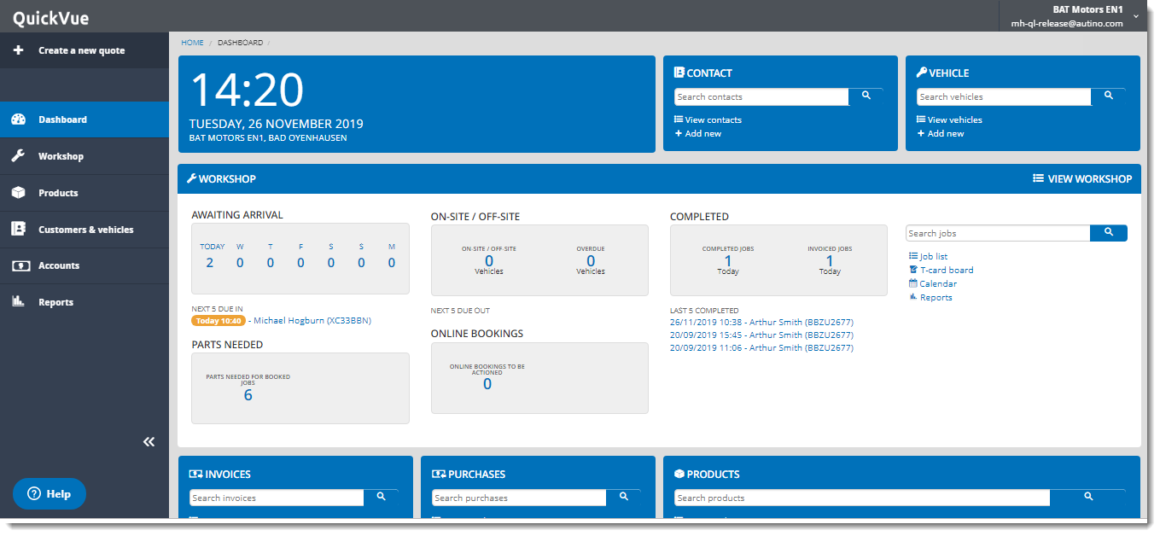

The **QuickVue Dashboard** allows you to quickly perform some key tasks from one place. You can use the **QuickVue Dashboard** to:

* view and create data, such as contacts and vehicles
* create invoices and purchases
* view and update pending actions (such as parts to be ordered, bookings and jobs in different statuses); all the numbers shown in the **QuickVue Dashboard** are clickable links to the underlying task

## QuickVue Workshop

The **QuickVue Workshop** is where you manage the car repair process. The key concepts are summarised below.

**Quote** All processes in QuickVue start from a quote. The quote is an overview of repairs and checks requested by a customer. A quote can be created manually in QuickVue or generated automatically through online booking. A quote can (but does not have to) include customer and vehicle details.

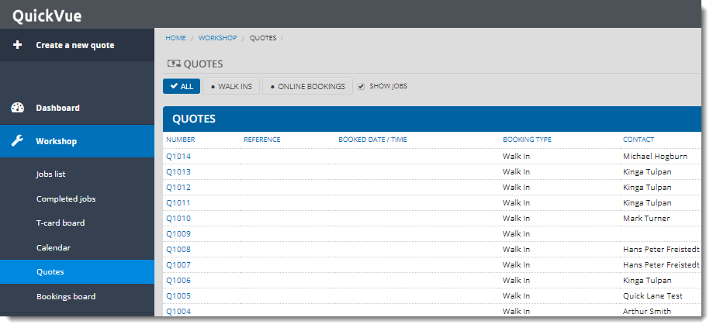

**Job** Converting a quote to a job is synonymous with accepting a quote from a garage or customer. The job includes detailed information about the customer, vehicle and all the work carried out on the vehicle. Jobs in QuickVue are managed through the **T-card board**. It allows the garage owner, technicians, workshop manager, service manager, service advisors and receptionists to follow the progress of the car during the work undertaken.

**Invoice** The last step before the customer leaves the workshop is the invoice.

The basic flow through the **QuickVue Workshop** is as follows:

Note: You can click on each stage of the flow to see details of the underlying procedure.

## T-card board and Bookings board

The **QuickVue Workshop** includes two features for viewing and managing your scheduled jobs.

The T-card board is a graphical tool for viewing the status of your daily jobs and moving them through the workflow.

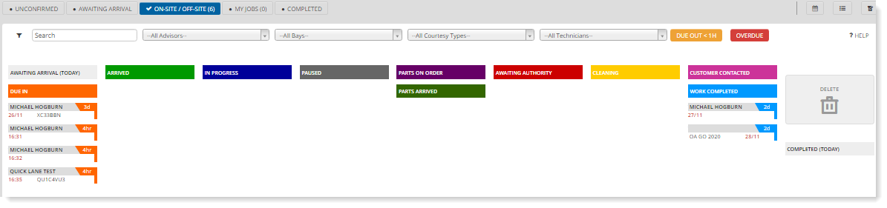

The Bookings board gives a calendar of bookings scheduled on a particular day.

# Getting started with QuickVue

To get started with QuickVue, you need an internet browser and a QuickVue user account. If you do not have a user account, you must first register as a new user.

Note: For best results, we recommend you use a Chrome browser.

## Register a new user account

1. Open the QuickVue registration email invitation you received and click **Complete Registration**.

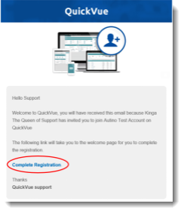

1. In the QuickVue login page, click **Create new account**.

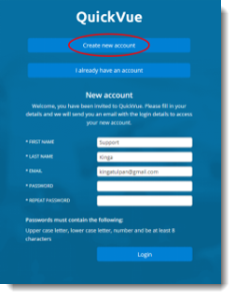

1. Enter your user details, ensuring that your password meets the complexity requirements, then click **Login**.

## Log in with an existing user account

1. If you have an invitation email, click the **Complete registration** link, then click **I already have an account.**

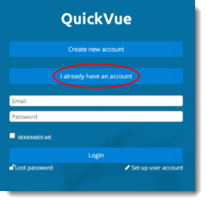

1. Otherwise, open an internet browser and enter the QuickVue web address.
2. Enter your email address and password, then click **Login**.

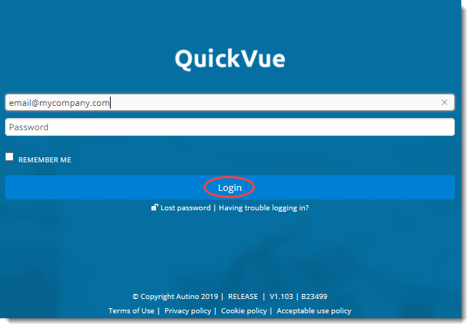

After login, choose your location from the list. The dashboard for your location is displayed.

## Get help

You can get help at any time by clicking the help icon:



This displays a window from which you can access the knowledge base or chat live to a member of staff:

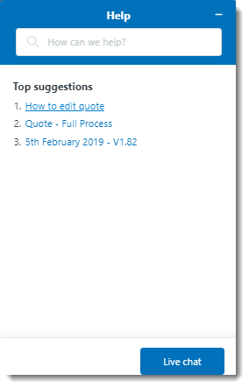

# Setting up data in QuickVue

You can set up any of the following types of data from the **QuickVue Dashboard**:

* Contacts (including customers, suppliers and staff)
* Vehicles
* Products

Each of the **+ Add new** shortcuts in the **QuickVue Dashboard** takes you to the associated menu function.

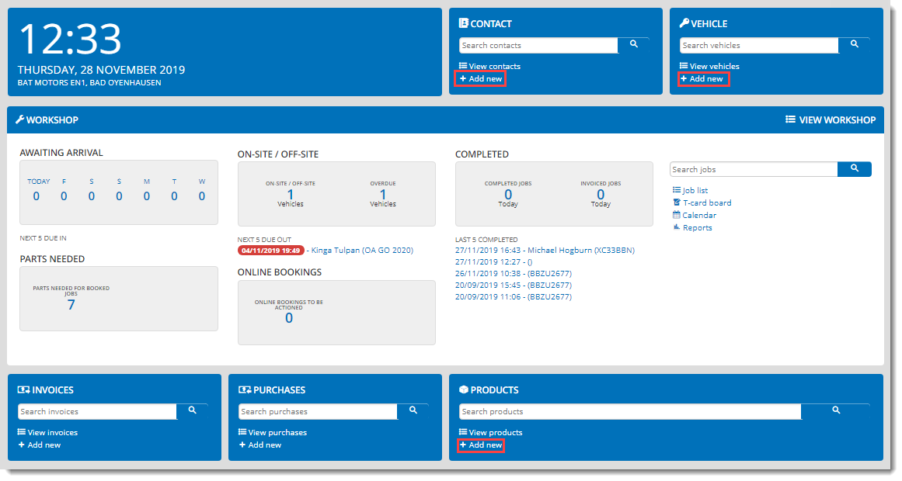

Note that although the **QuickVue Dashboard** provides a convenient way of managing data in one place, you do not need to set up the data before you can create new repairs. You can also create all of the data types listed as part of the procedures documented in the Managing customer repairs in QuickVue section.

## Create a new contact

1. Click **+ Add New** in the **CONTACT** section of the **QuickVue Dashboard** (or **Customers** in the **Customers & vehicles** menu).
2. Complete the fields as required. You can look up addresses by name or postcode.

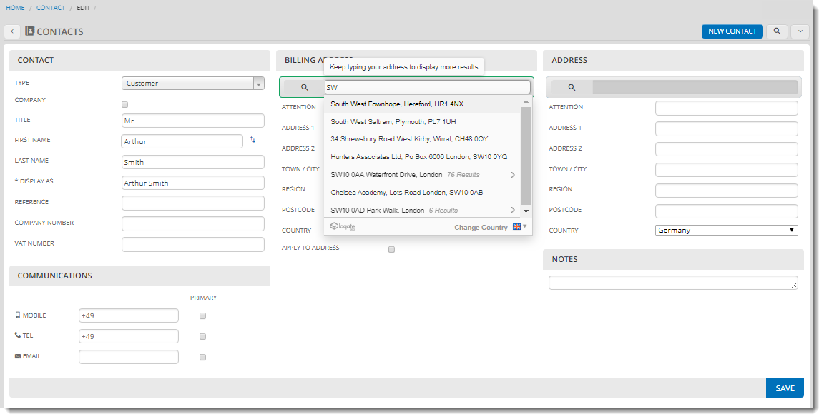

1. Click **SAVE**. Details of the new customer are displayed along with any associated information such as vehicles and quotes, if any.

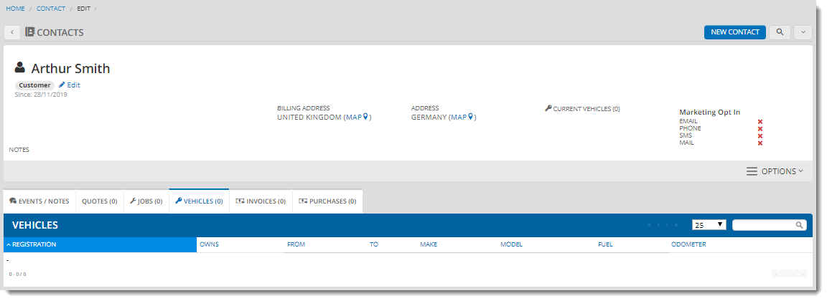

## Create a new vehicle

1. Click **+ Add New** in the **VEHICLE** section of the **QuickVue Dashboard** (or **Vehicles** in the **Customers & vehicles** menu).
2. Complete the details of the vehicle as required, plus information such as the due date of the next service and the warranty end date.

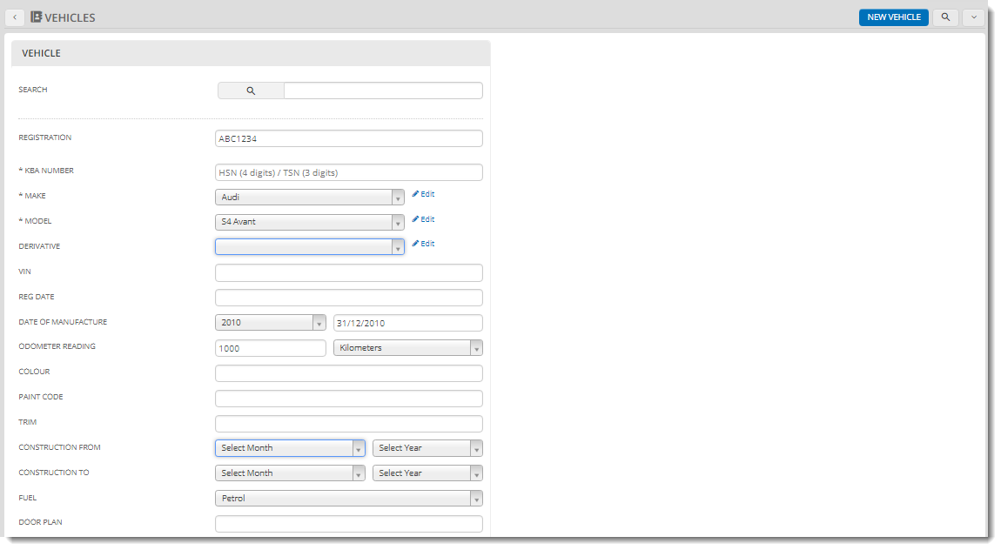

1. Click **SAVE**. Details of the new vehicle are displayed along with any associated information such as the customer and quotes, if any.

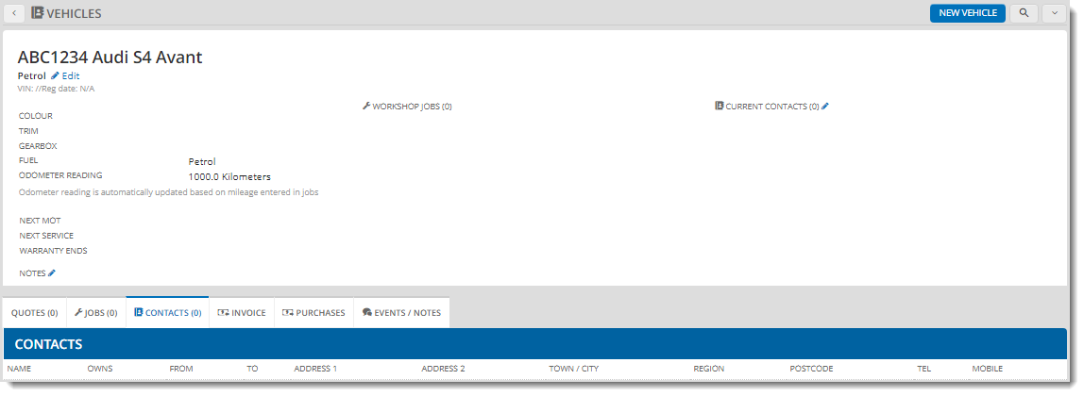

## Create a new product

1. Click **+ Add New** in the **PRODUCTS** section of the **QuickVue Dashboard** (or **Products** in the **Products** menu).
2. Complete the details of the product as required. If you want to track the stock through QuickVue, check the **TRACKABLE INVENTORY** check box, then complete the other stock details, such as if this is **IMPRESS STOCK** (consignment stock).

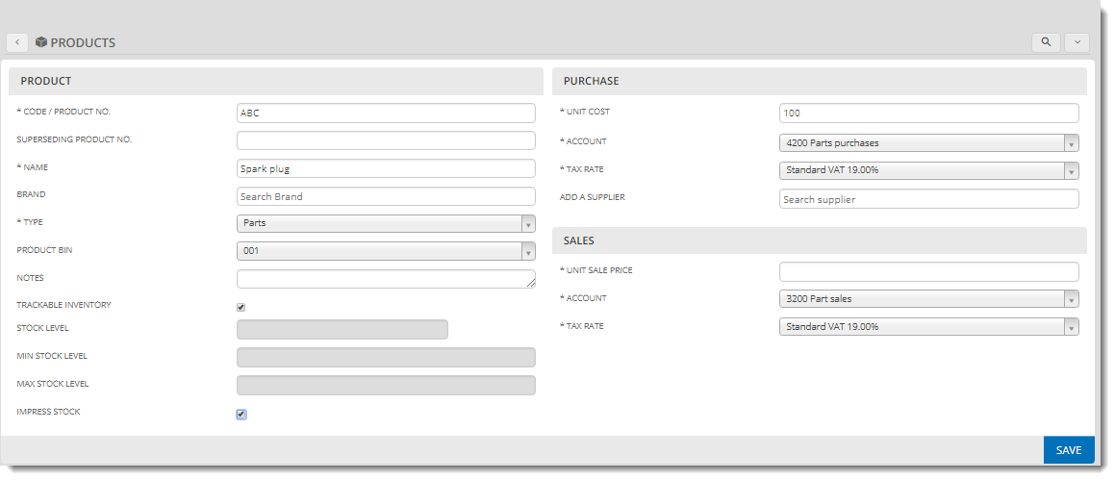

1. Click **Edit Stock Level** to update the stock details.

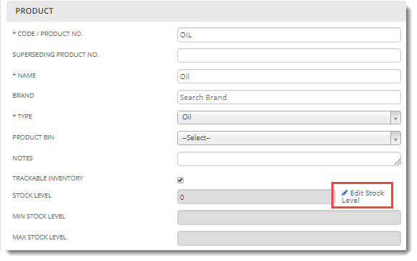

1. Specify the stock details in the **INVENTORY** page and click **Edit Product** to return to the product page when you have finished.

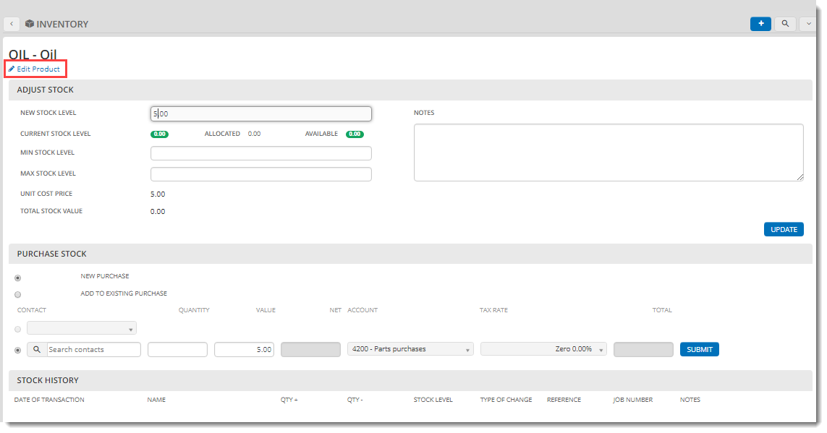

1. Click **SAVE** to save the product.

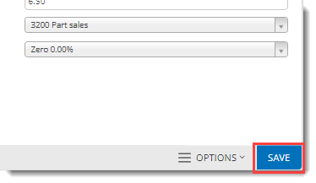

You can now see your product displayed in the products list. You can click directly on the **AVAILABLE STOCK** link to update the stock in the **INVENTORY** page.

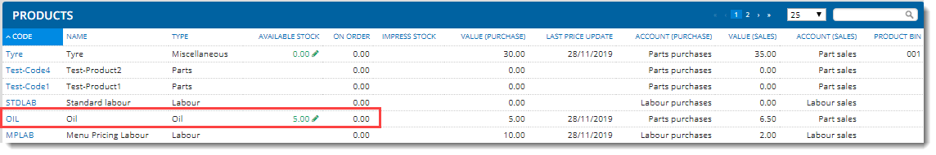

Note: If you add **COLER** parts as part of a new quote, they are created and tracked in the same way as other products. See Create a new quote for more details.

## Create a new repair template

If you want to use repair templates when creating new quotes, you need to create them before you start.

1. Click **Products > Repair templates**.

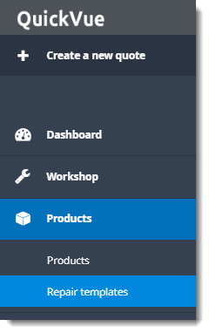

1. Click **NEW REPAIR TEMPLATE**.

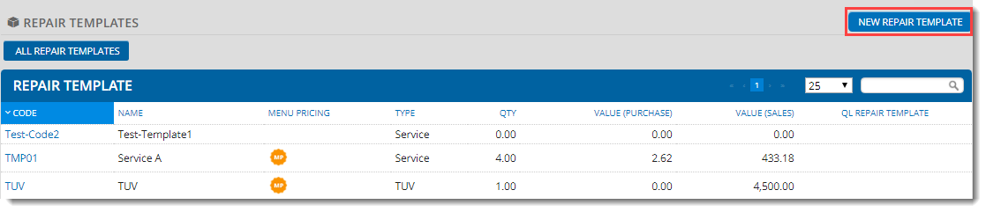

1. Specify the general information about the repair template:

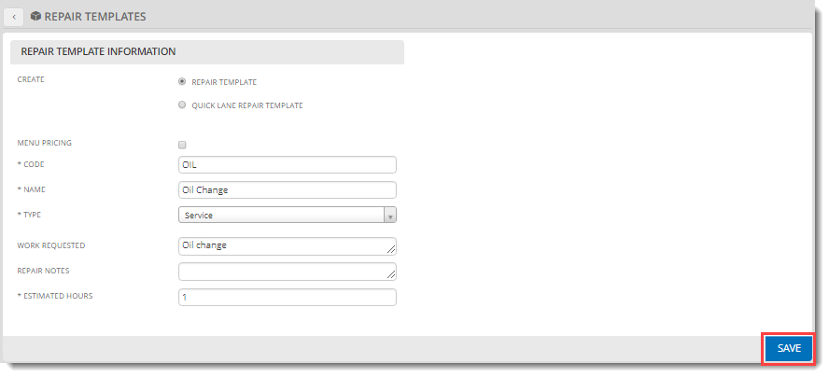

* + choose **REPAIR TEMPLATE**
  + check the **MENU PRICING** checkbox if you require menu pricing (a fixed price for the whole template, which means if you override the price of any of the template items during quote creation, the other prices are adjusted accordingly); if you choose menu pricing you must also specify the **MENU PRICE**

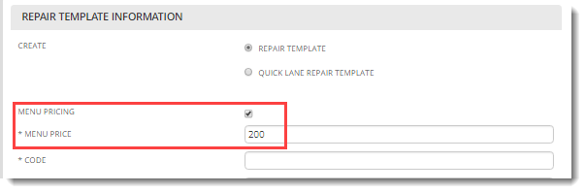

1. Click **SAVE**. The repair template is saved with a labour item already added.

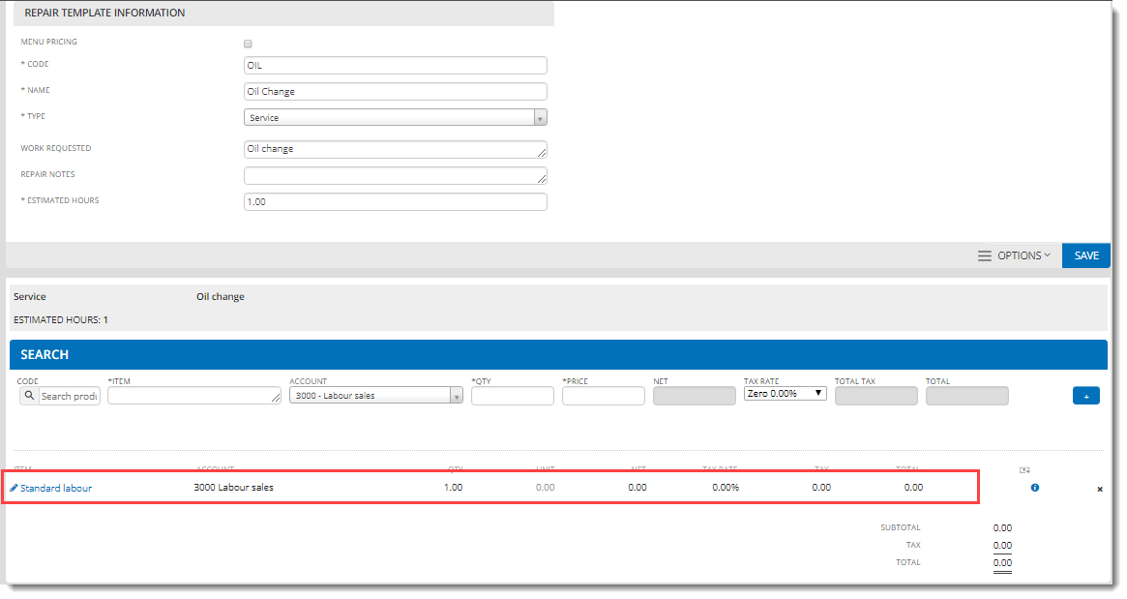

1. Add any other repair items you require to the template:
   1. Enter the item code.
   2. Update the pricing and other details.
   3. Click the plus icon.

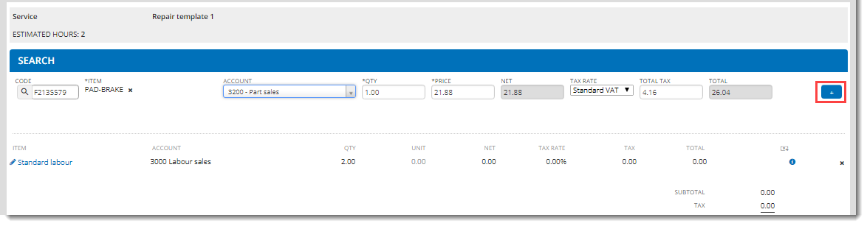

Tip: You can remove unrequired items by clicking the cross next to the item.

1. Click **SAVE** in the top section of the page when you have finished updating the template. It now appears in the **Repair templates** list.

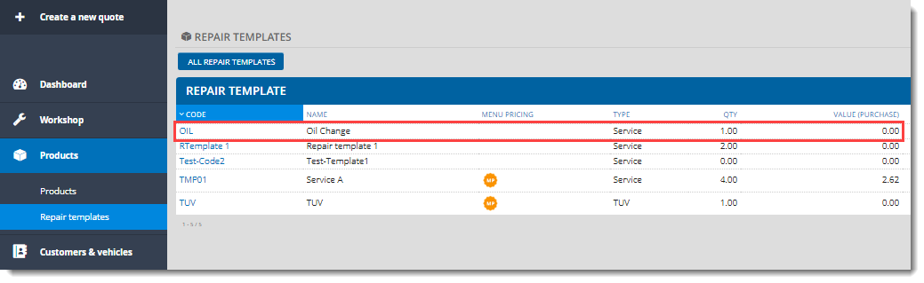

To delete a repair template:

1. Open the repair template from the list.
2. Click the **OPTIONS** menu and select **Delete**.

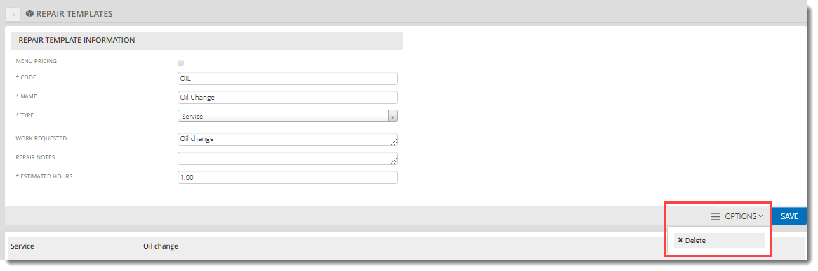

# Managing customer repairs in QuickVue

This section explains how to create new repair quotes, convert repairs into jobs and invoice jobs.

## Create a new quote

The quote is a record of the customer interaction, including the details of the customer and vehicle. Details of the work to be carried out and the associated repairs and costs are added in the next procedure.

To create a quote:

1. Click **Create a new quote**.

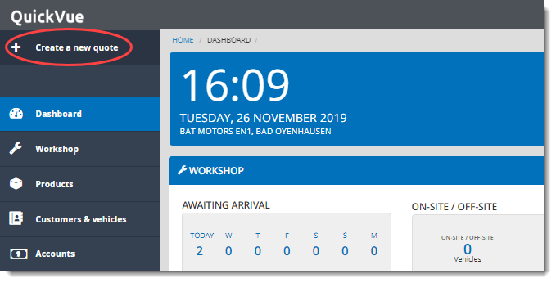

1. In the new window that opens, add a new customer and/or vehicle, if required (note that if you do not add the customer and vehicle details now, you must add them when you create the job):
2. Click **Add new vehicle** to specify new vehicle details or look up an existing vehicle.
3. Specify new customer details or look up an existing customer.

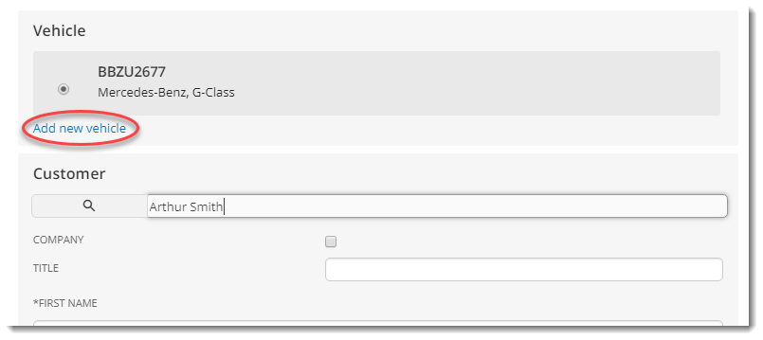

1. Scroll to the bottom of the vehicle and customer window and select the customer’s marketing preferences.
2. Click **PRINT** to open the customer agreement document in a new tab, where you can print it and give it the customer for signature. You cannot save the customer details until you have done this.

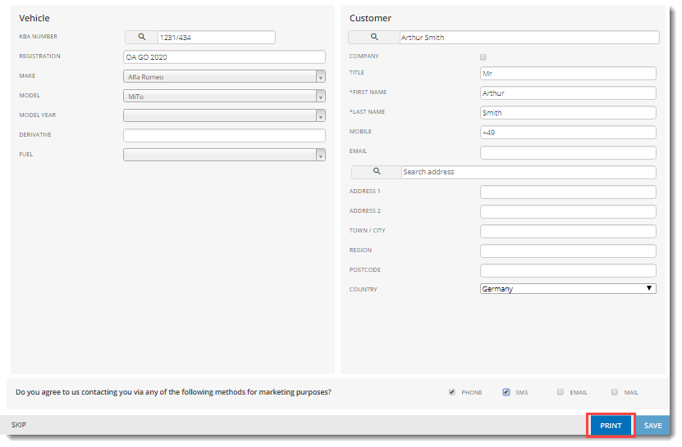

1. Click **SAVE**.

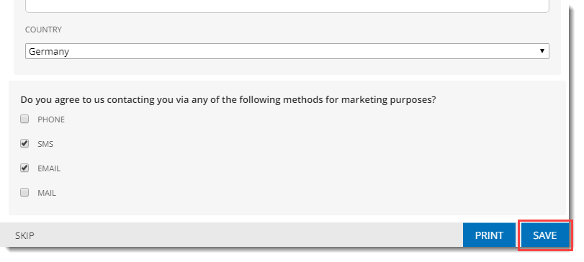

A new **walk-in booking** quote is created with a unique ID.

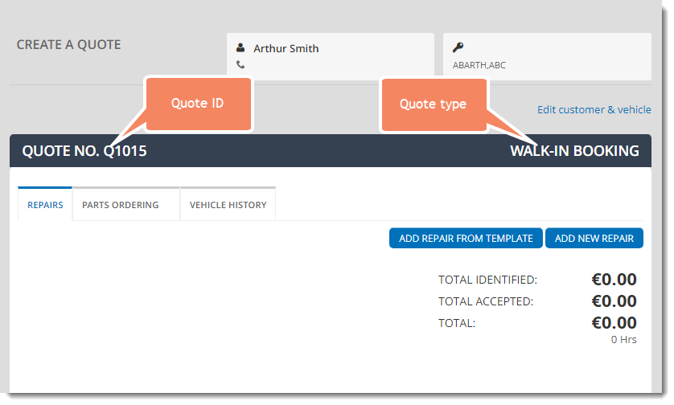

## **Add repairs to the quote**

Repairs are the work to be carried out on the car and are made up of one or more **line items** (the items needed for the repair, such as parts and labour).

QuickVue provides two ways of adding repairs:

* pre-defined repair templates (see Create a new repair template for details of how to create repair templates)
* manual specification

Note: You can combine both types in a single quote, and you can add as many repairs as you like.

To add a new repair:

1. If you are returning to a quote created earlier, open it first by clicking **Quotes** in the **Workshop** menu, and selecting it from the list.

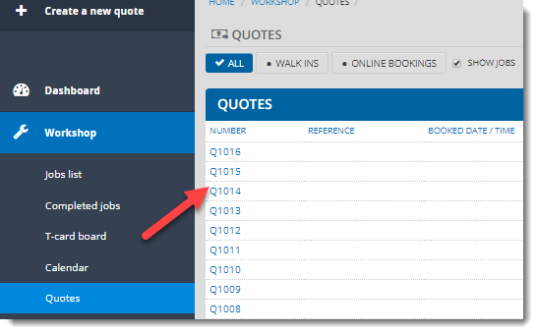

1. (Optional) Click the **VEHICLE HISTORY** tab to check for any items flagged for follow-up during previous EVHC checks on this vehicle, then add repairs for them if required by the customer.

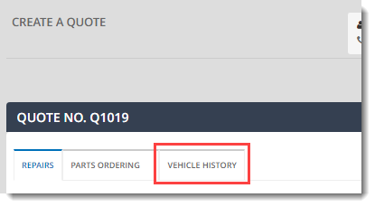

1. If you want to add repairs from a repair template, click **ADD REPAIR FROM TEMPLATE**, then select the template type and name in the window displayed.

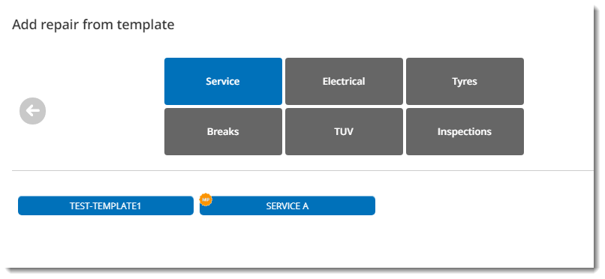

1. The repair line items are added from the template to the quote. Click **Edit** if you want to add, update or delete any line items.

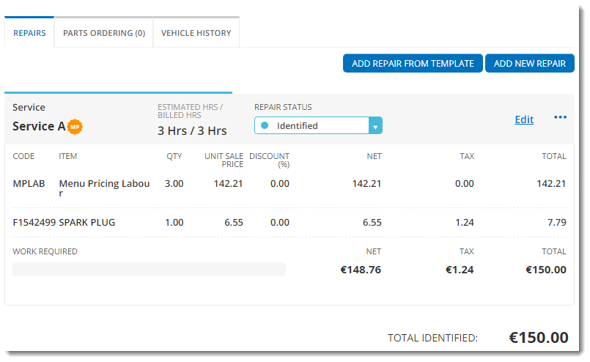

1. If you want to manually specify a new repair, click **ADD NEW REPAIR**, then:
2. Specify the general information about the repair (the type of repair, details of the work and an estimate of the number of hours it will take).

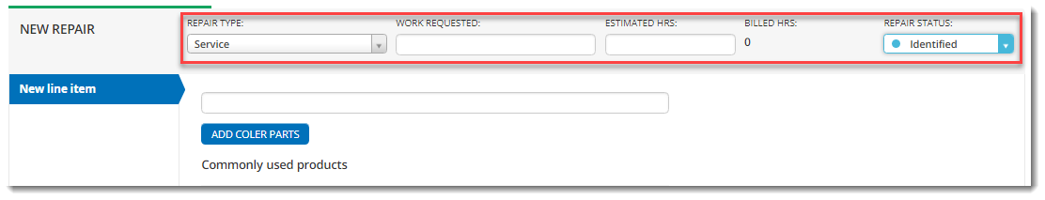

1. Add a new line item (parts and other associated costs). You can either:

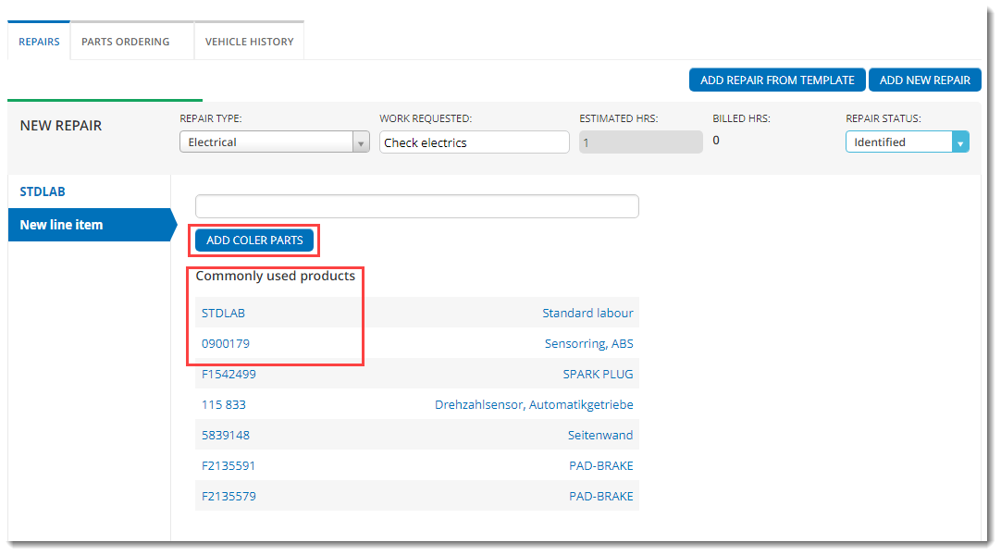

* add a commonly used product from the list by clicking the link, then specify the details of the product. In this example, there is no stock for the product, so you are prompted to order more; you can do this by editing the stock level in the products list (see Create a new product for more details).

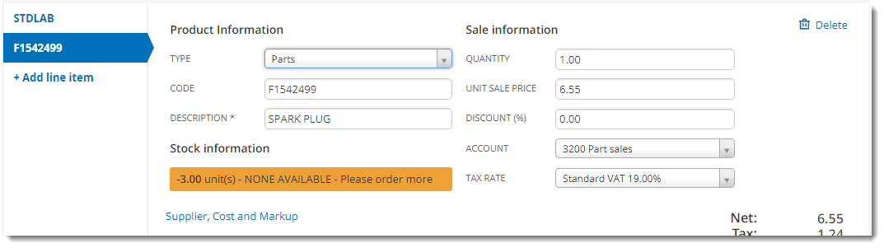

If the product is not listed, you can search for it in the search bar and create it if it does not exist (see Create a new product for details).

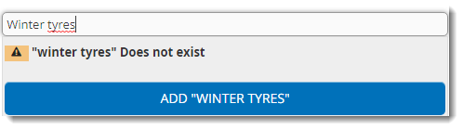

* click **ADD COLER PARTS** to search for a part in the third-party parts finder. The parts finder for your country is loaded with a relevant product list, based on the KBA or registration number, if provided.

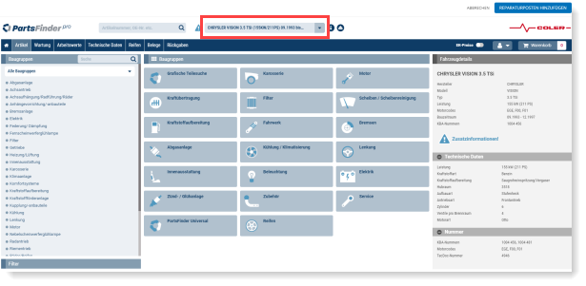

If not, enter your vehicle details, then search for the product and add it to the basket. Click **Add to QuickVue repair** to add it to the QuickVue quote; the parts are now visible in the quote’s **PARTS ORDERING** tab.

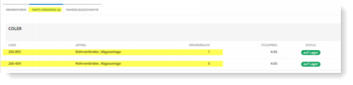

Note: A labour line item is added by default to all quotes. You can delete it if required.

* 1. Add more line items in the same way by clicking **+ Add line item**.
  2. Once you have finished adding your line items, click **Save repair**. The new repair is saved with **Identified** status.

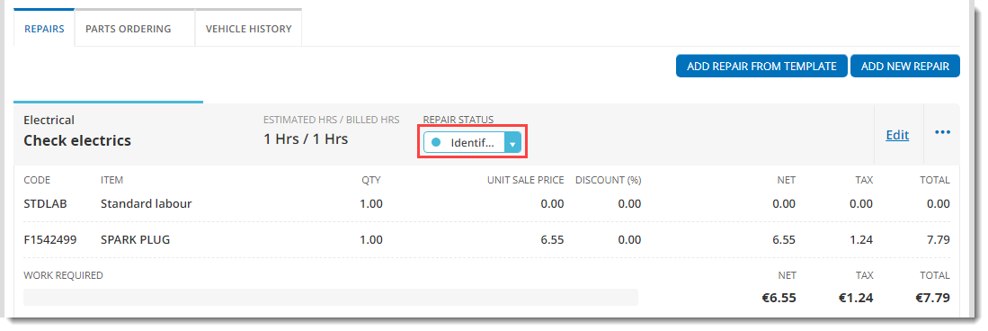

To edit or delete a repair:

1. Edit the repair by clicking **Edit** and repeating the steps above.

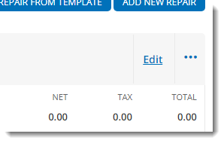

1. Delete the repair by clicking  and selecting **Delete Repair**.

## View or update a quote

1. If you are returning to a quote created earlier, open it first by clicking **Quotes** in the **Workshop** menu, and selecting it from the list.



1. If you want to add or edit customer / vehicle details, click **Add customer & vehicle** or **Edit customer & vehicle**.

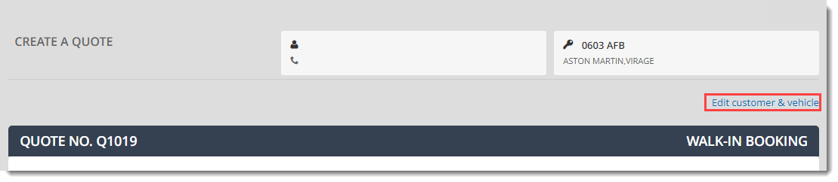

1. Add or update the vehicle and/or customer details, if required, then click **SAVE**.

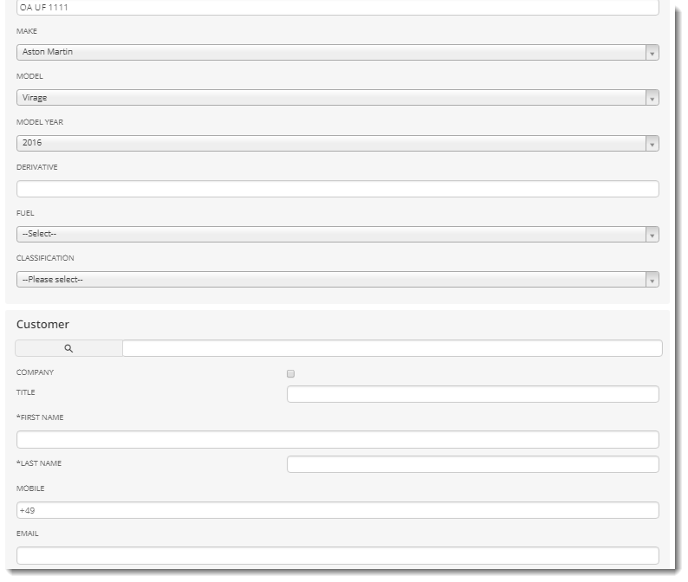

1. If you want to add or edit repairs, follow the instructions in Add repairs to the quote).

## Print or email a quote

1. If you are returning to a quote created earlier, open it first by clicking **Quotes** in the **Workshop** menu, and selecting it from the list.



1. Scroll to the bottom of the quote and click:

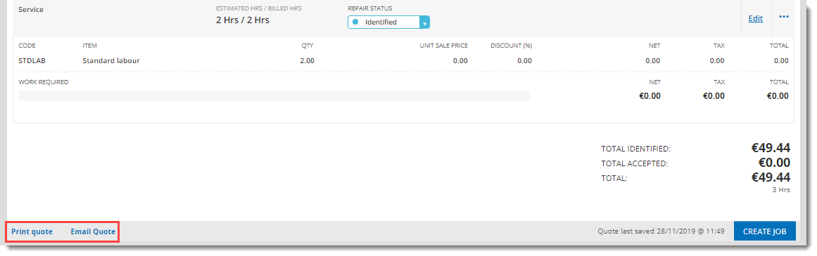

* + **Print quote** to print the quote; a printable version of the quote opens in a new browser tab
  + **Email quote** to email the quote; complete the email details in the new section which appears at the bottom of the quote, then click **SEND**

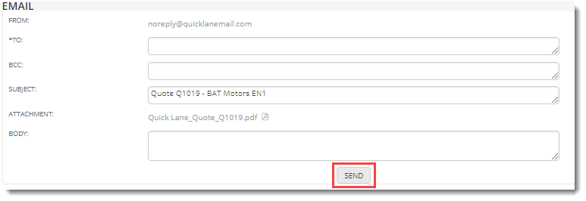

## Convert the quote to a job

When you have finished creating your quote and adding the repairs to it, you need to convert it into a **job**. The job includes details of when and where in the centre the work will be carried out.

Note: You can also use this procedure to convert quotes created through online bookings into jobs.

To create a job:

1. If you are returning to a quote created earlier, open it first by clicking **Quotes** in the **Workshop** menu, and selecting it from the list.



1. Update the status of the repairs to **Accepted**, **Declined** or **Follow-up**, based on the customer’s preference. In this example the customer has accepted one of the repairs and declined the other.

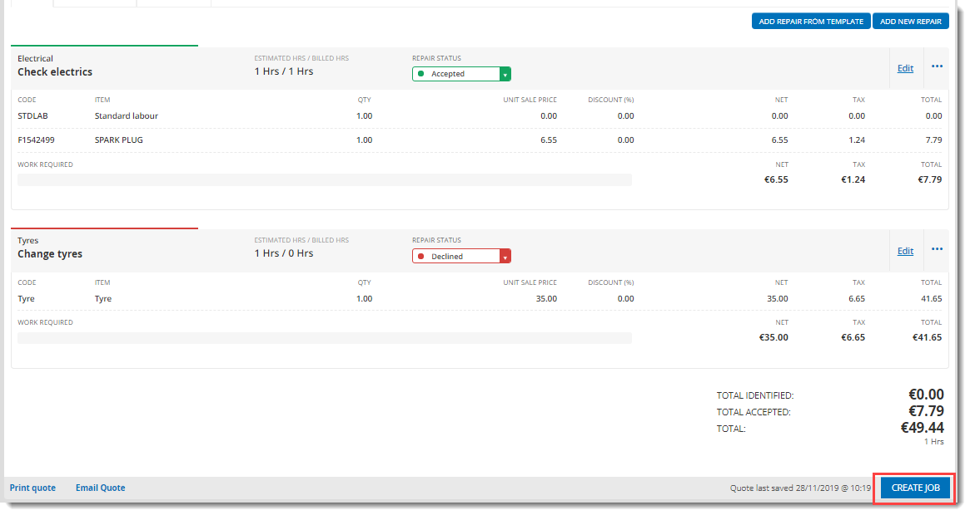

1. Click **CREATE JOB**.
2. QuickVue displays the details of the job in a new window. Check the customer and vehicle details, then update the other details, such as the date and time of the job, the bay where the job will take place, the technician and the type of courtesy car provided, if any. You can also update the job status at this point.

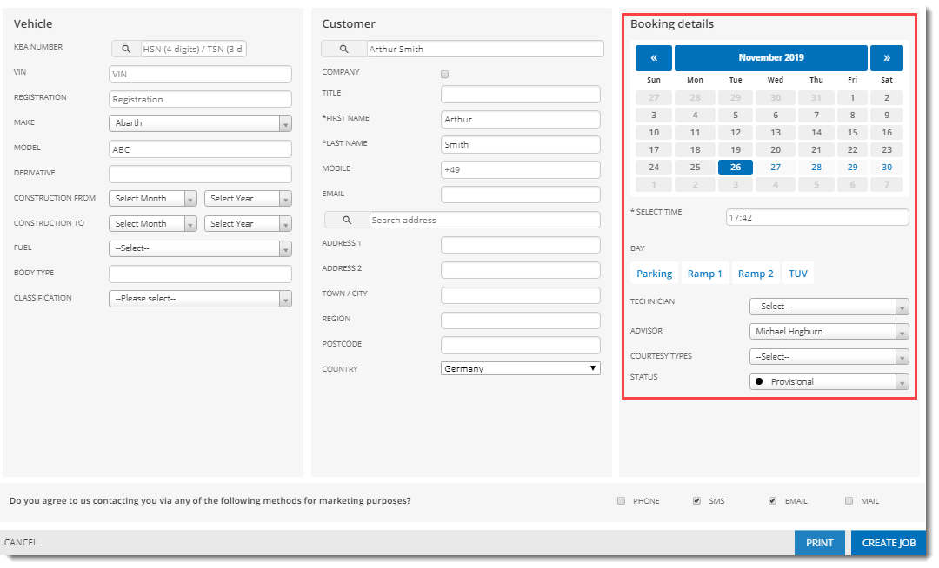

1. Specify the customer’s marketing preferences, then click **PRINT** to open a printable copy of the customer agreement for the customer to sign.
2. If you added any **COLER** parts to the quote, click the **PARTS ORDERING** tab and check the checkboxes next to the items you want to order.

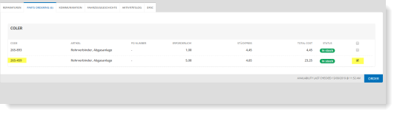

1. Click **CREATE JOB**.

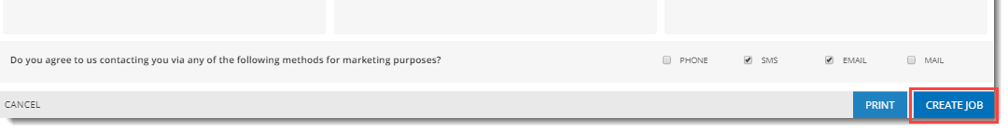

QuickVue confirms creation of the new job and displays it at the top of the page.

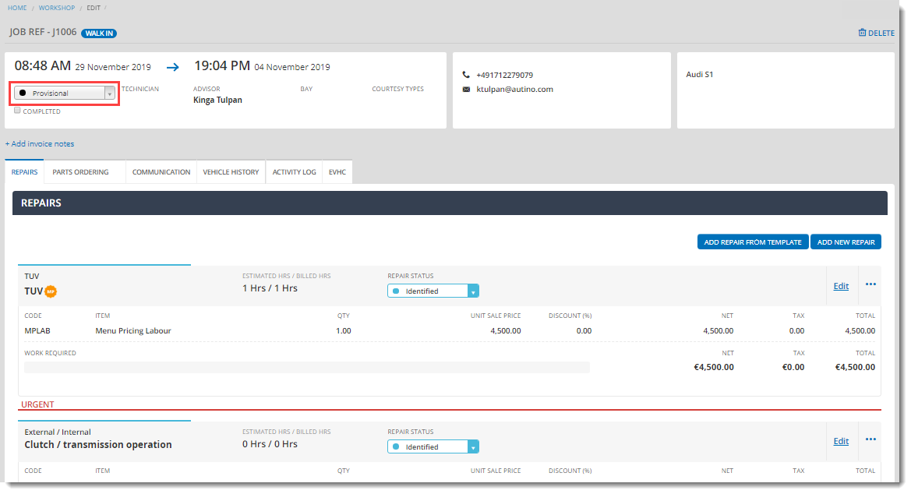

By default, jobs are created with a **Provisional** status. You can update the status in the drop-down list, or return to it later and update it (see View or update jobs).

## Update the customer

You have several different options for communicating job updates to your customer. You can telephone or email them using the contact details registered in the job, you can use the SMS messaging feature, or you can use the integrated messaging system (if enabled).

If the integrated messaging system is enabled, the customer receives a link to their booking when you convert a quote to a job:

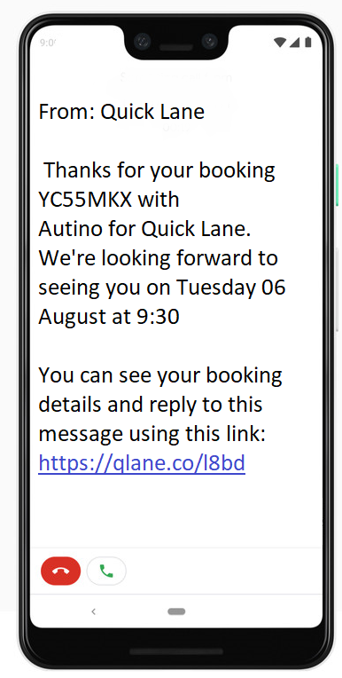

To update your customer by SMS from a job:

1. If you are returning to a job created earlier, open it first by clicking **Jobs list** in the **Workshop** menu, and selecting it from the list.

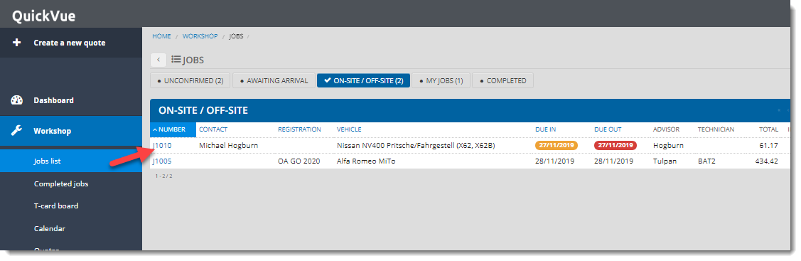

1. In the **COMMUNICATION** tab, click **NEW MESSAGE**.

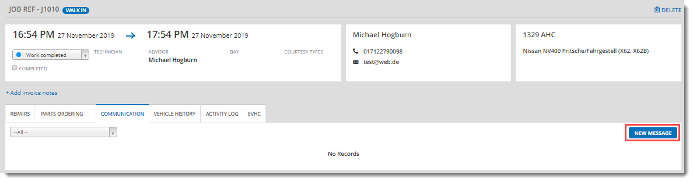

1. Type your message, then click **Customer SMS**.

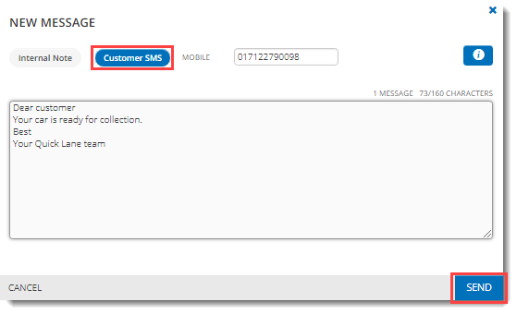

1. Check the mobile number is correct, then click **SEND**.
2. Details of messages sent are saved in the **COMMUNICATION** tab.

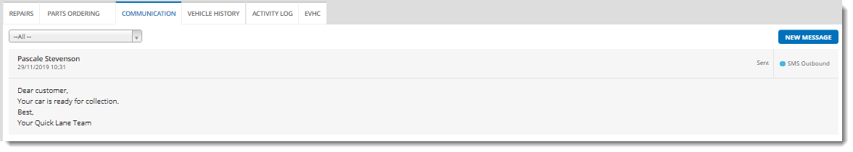

To update the customer using the integrated messaging system:

1. Type your message in the messaging window in the job and click **SEND**. The customer is notified of the new message by SMS and/or email.

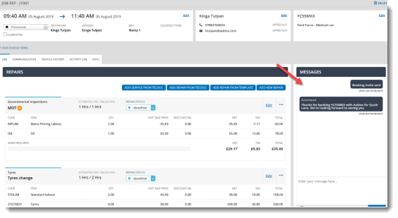

1. When the customer replies, a speech bubble appears at the top of the page. Click the bubble and select the message to read it and reply.

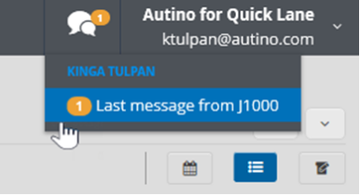

## Perform an EVHC

Once you have created a new job, you can perform an EVHC (Electronic Vehicle Health Check) to identify any additional repairs, if required.

1. If you are returning to a job created earlier, open it first by clicking **Jobs list** in the **Workshop** menu, and selecting it from the list.



1. Click the **EVHC** tab.

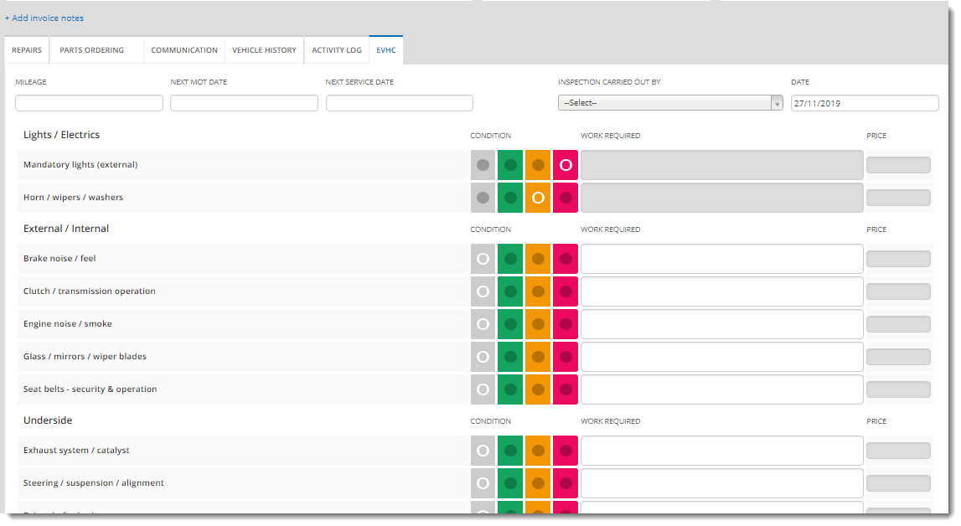

1. Go through the EVHC checklist, setting the condition of each item checked to green, amber or red.
2. Specify other details for each item, such as the work required and the price. For brake pads you can set a thickness in mm, which automatically updates the condition based on the value entered (you can manually modify the condition if manufacturer regulations differ from the standards set in QuickVue).
3. Click **TYRES & WHEELS CHECK** to perform a detailed check of the tyres and wheels.

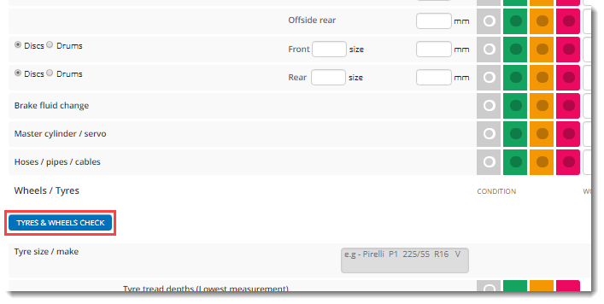

1. Perform the check on each tyre, clicking **NEXT TYRE** to move on to the next tyre, and **FINISH** when done, to return to the EVHC page. 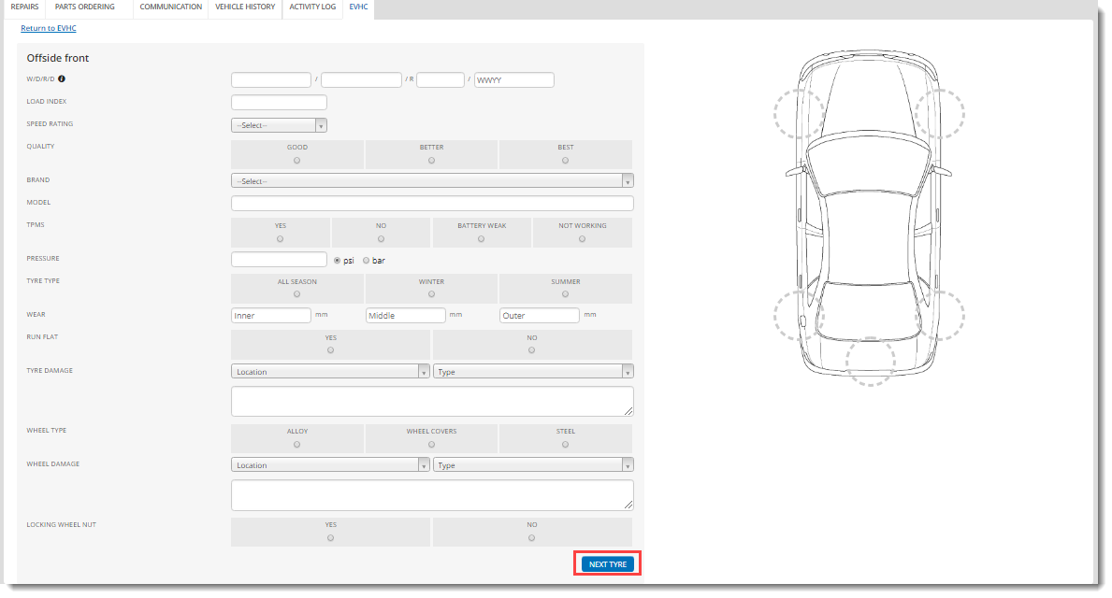

The EVHC page is populated with the information.

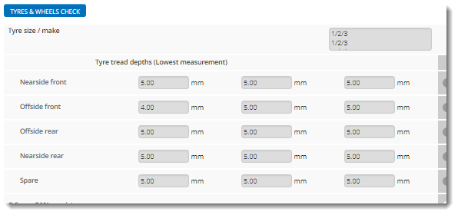

1. Update the other details in the EVHC header as required, such as the date of the EVHC, who carried out the inspection, the car’s mileage, next service date, etc.

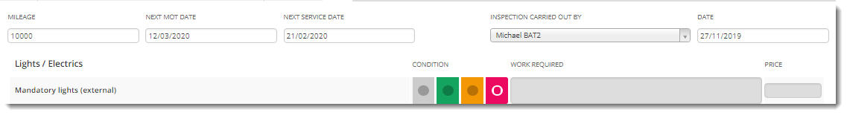

1. When you have finished, scroll to the bottom of the screen, where you can print and save the EVHC.

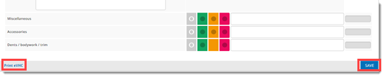

Any items flagged as red or amber are now added to the job for the technician/advisor to review and discuss with the customer.

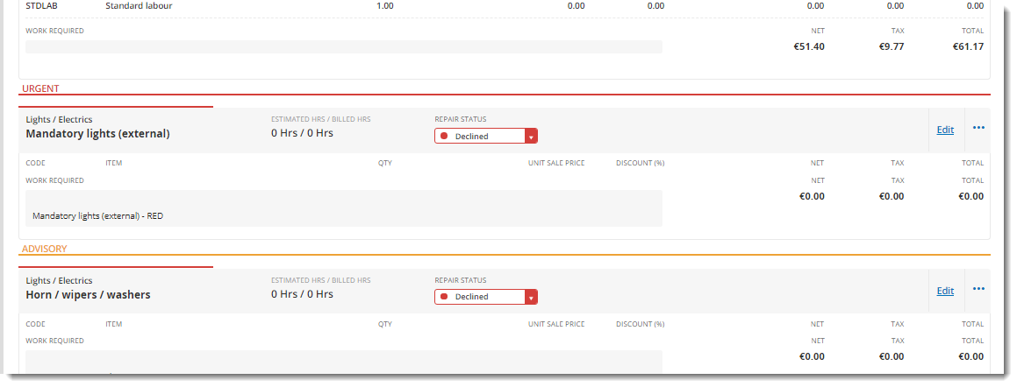

If the customer chooses to accept the repairs straight away, they are repaired and invoiced as part of the same job. The customer can also decline the repairs, or choose to set them to a follow-up status, to be revisited at a later date. These repairs can then be identified in the history when creating a new quote for the same car.

## View or update a job

After you create a job, you can go back into it and modify it. For example, you can add new items to the job and update its status as it moves through the workflow.

The **QuickVue Workshop** includes three different functions for viewing and managing jobs after their creation:

* **Jobs list**, which lists all your jobs by status along with a link to update them
* **Completed jobs**, which provides the same functionality as **Jobs list**, but lists jobs in **Work completed** status by default
* **T-card board**, a graphical tool for dragging jobs scheduled for today through the different workflow stages, dynamically changing their status

To view or update jobs**:**

1. Click **Jobs list**, then click the tab relating to the status of your job (or **Completed jobs**, if you prefer to see completed jobs by default).

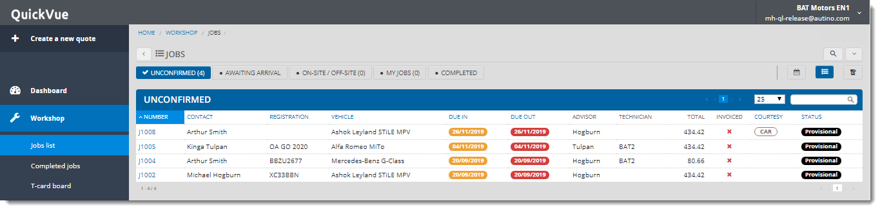

1. Search for your job in the list. You can use the search facility at the top right or sort the column names.
2. Click the job number in the first column to view its details.

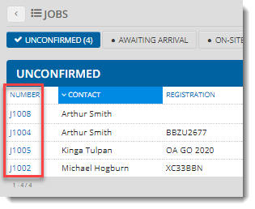

1. You can view and update the following job information. In the:
   * Job header, you can delete the job, update the status of the job or add invoice notes

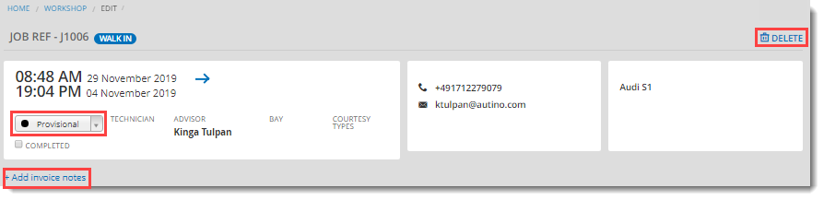

* + **REPAIRS** tab, you can add new repairs, print or email the job card, print the technician card or create an invoice (note that this option is only enabled when at least one repair is set to **Accepted** status)

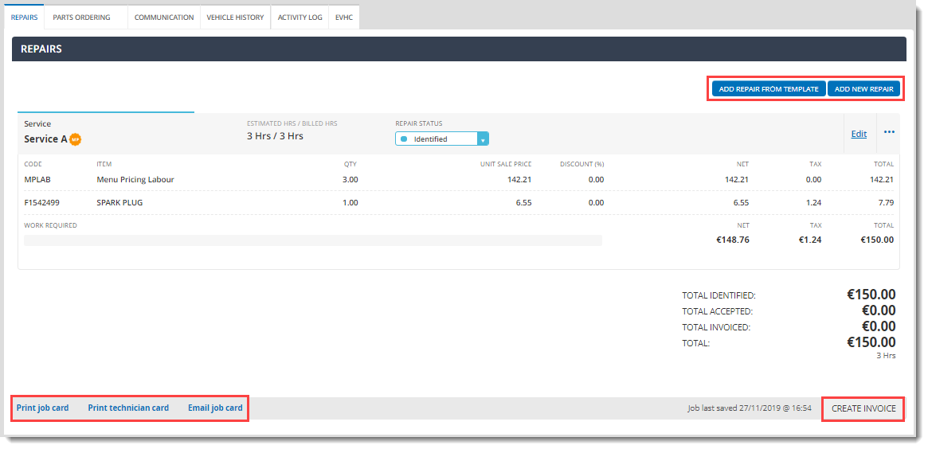

* + **COMMUNICATION tab, you can write internal notes on the job or send the customer an SMS (see** Update the customer**)**
  + **VEHICLE HISTORY** tab, you can view a full vehicle history (quotes, jobs and invoices) and opportunities (all potential repairs from quotes and jobs for the same customer); you can add any opportunities from the list to the current job by changing them to **Accepted** status

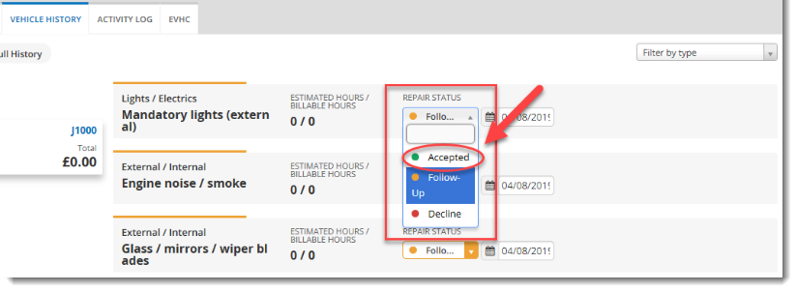

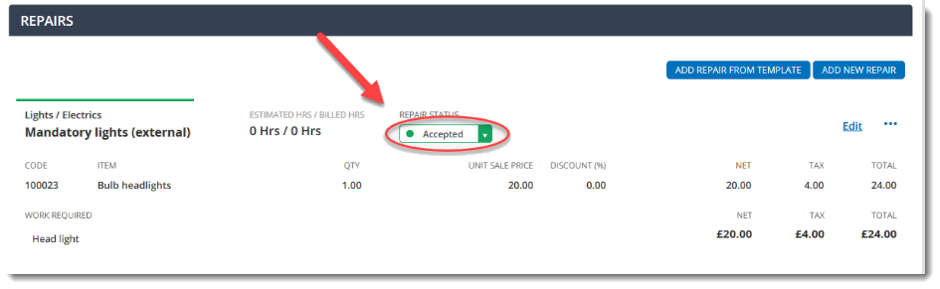

* + **ACTIVITY LOG** tab, you can view details of all activities performed related to the job, including links to related documents (invoices, quotes, etc.)

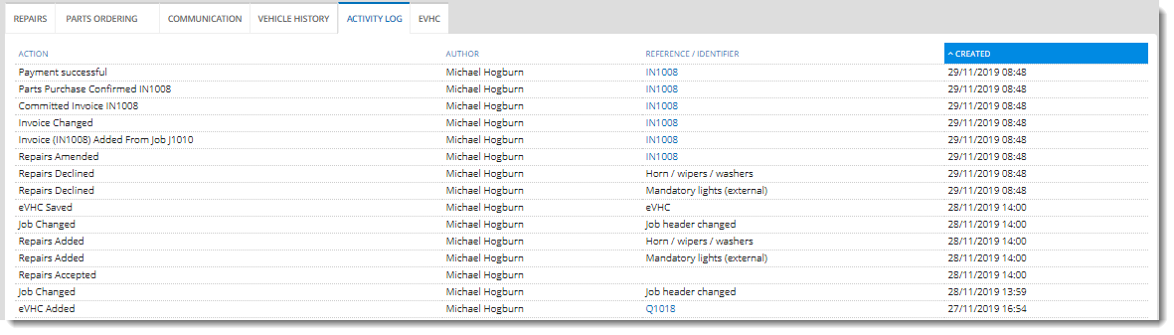

* + **EVHC** tab, you can perform an EVHC on the current vehicle (see Perform an EVHC)

To view or update the progress of today’s jobs using the **T-card board**:

1. Click **T-card board**.

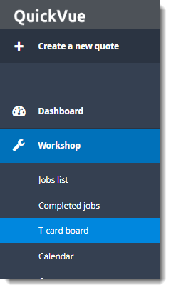

1. Click the status tab to view jobs in a different status, if required. You can also set filters or enter a search term to see specific jobs.

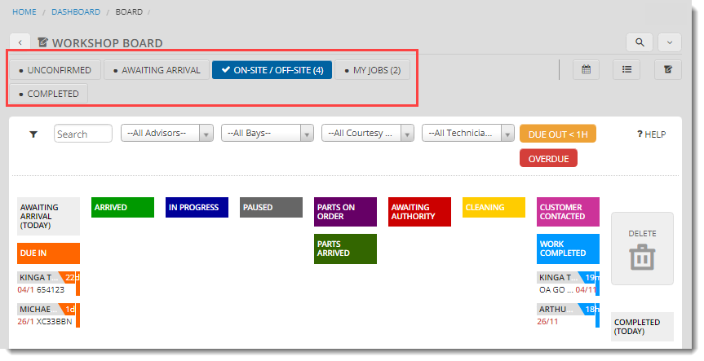

1. Click and hold a job, then drag it across to the column of the status you require (you can also drop it in **DELETE** if you want to delete it). In this example, a job has been dragged to **COMPLETED (TODAY)**.

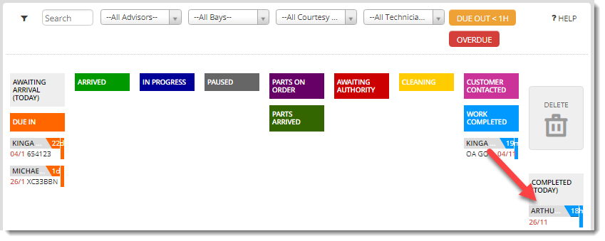

## Create an invoice

Once a job is completed, you can issue one or more invoices for it. You can only invoice repairs which have been accepted by the customer, and you can issue separate invoices for individual repairs, even if not all the repairs included in the job have been accepted.

To create a new invoice:

1. Create a new invoice using one of the following methods:
   * From the **QuickVue Dashboard**: click **+ Add new** in the **INVOICES** section
   * From the **Accounts > Invoices** menu: click **NEW INVOICE**
   * From an open job (or open the job using one of the methods described in View or update jobs if it is not open already):
2. Scroll down to the **REPAIRS** section and update any repairs for invoicing to **Accepted** status (if they are not already); QuickVue displays an **Updated record** confirmation.

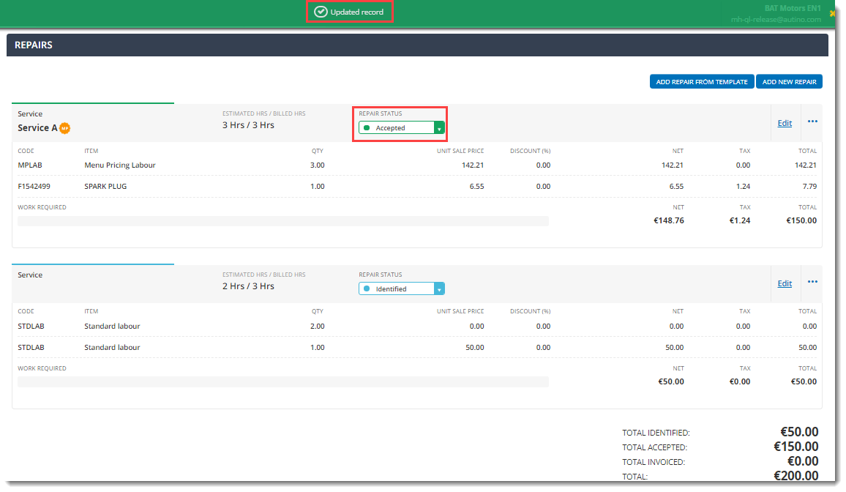

1. Click **CREATE INVOICE**.

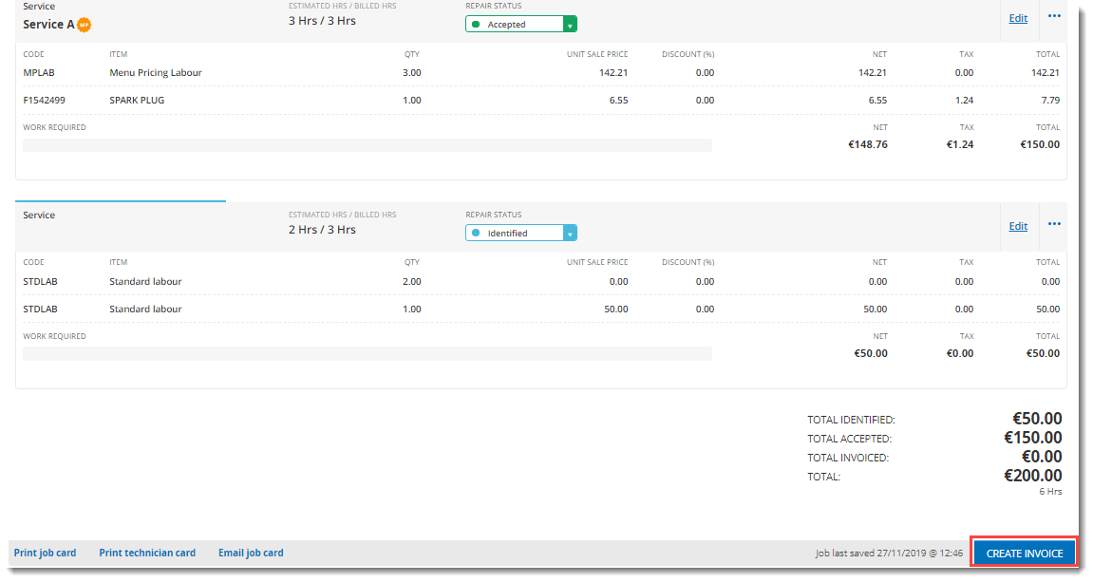

1. Click **CONFIRM** to confirm all the parts purchased for the job have been recorded in the job.

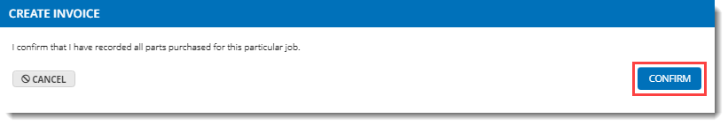

1. Enter the details of the invoice, including the contact details and invoice date. You can enter details of items and repairs at the bottom of the page.

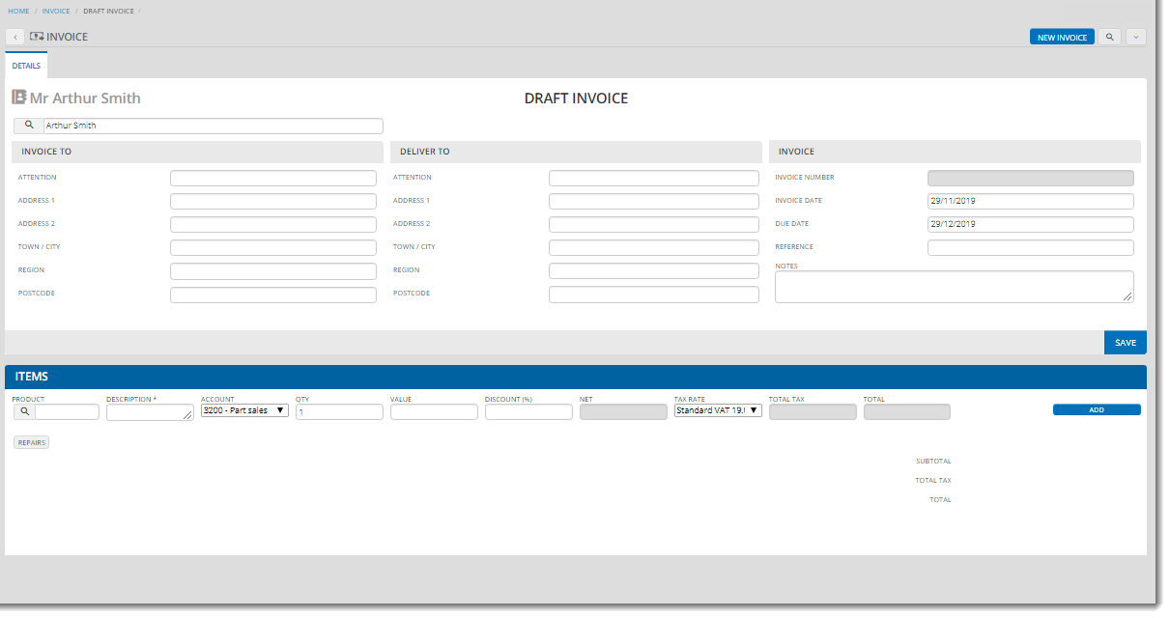

1. You can now save the draft invoice and/or commit it, depending on the method used to create the invoice.

If you are creating the invoice from a job:

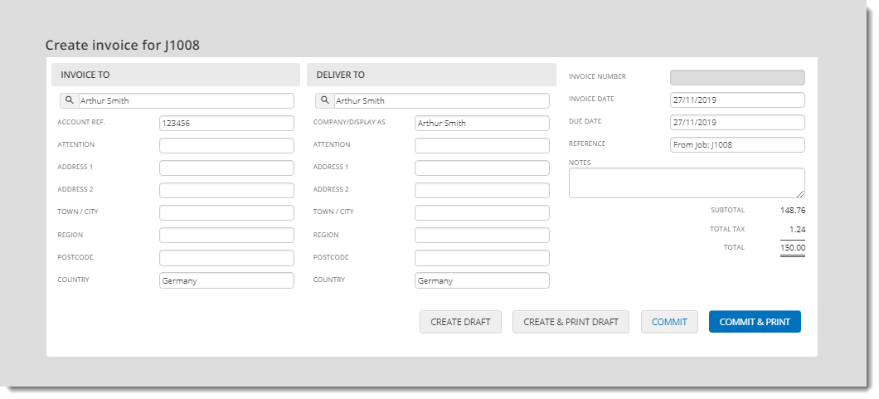

* + Click **COMMIT** or **COMMIT & PRINT** to commit the invoice; QuickVue:
    1. Displays an **Invoice committed** message at the top of the invoice
    2. Assigns a status of **Unpaid** to the invoice
    3. Displays a new section for adding payment details

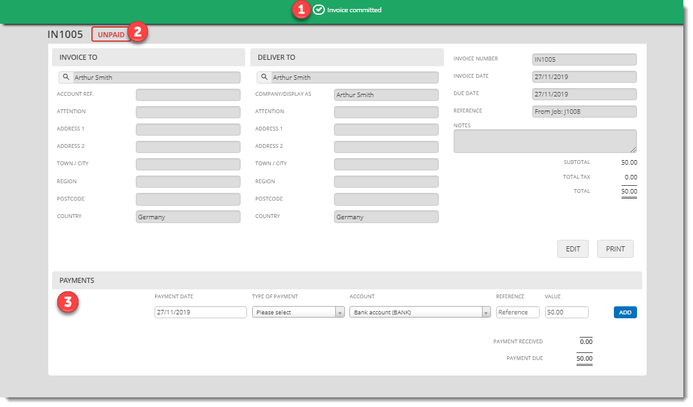

* + 1. Updates the status of the repair in the job window to **Invoiced**
    2. Displays a link to the unpaid invoice above the repair

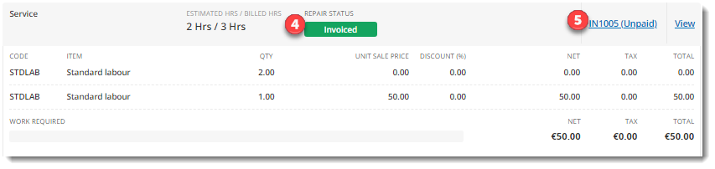

If your customer is ready to pay, you can now take payment (see Take payment for an invoice)

* + Click **CREATE DRAFT** or **CREATE & PRINT DRAFT** to create a draft invoice; QuickVue:
    1. Displays a **Draft invoice created** message at the top of the draft invoice

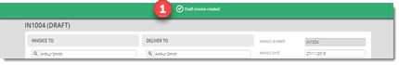

* + 1. Updates the status of the repair in the job window to **Invoiced**
    2. Displays a link to the draft invoice above the repair

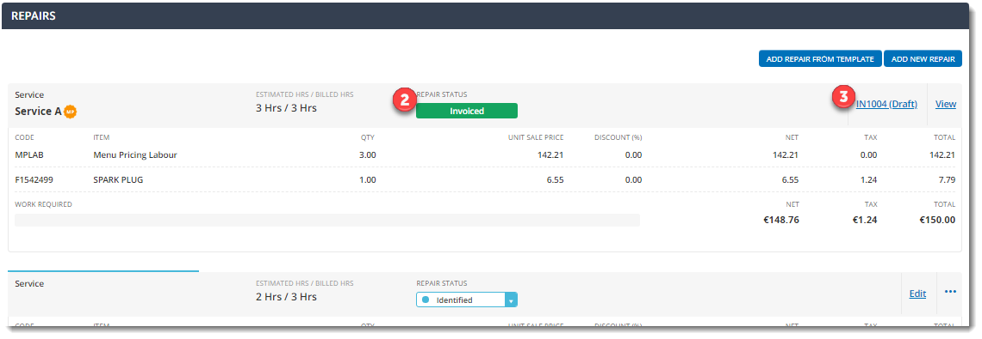

If you are creating the invoice from the **Accounts > Invoices** page (or **QuickVue Dashboard**):

* + Click **SAVE** to save the draft invoice; details of the items included in the invoice are displayed at the bottom of the screen, where you can add more items if required

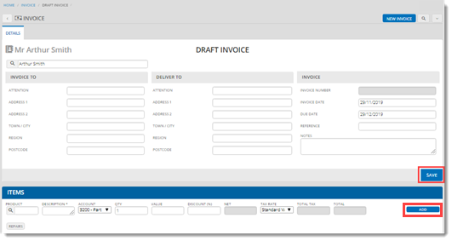

* + After you save the invoice, you can click **COMMIT** to commit the invoice, or you can email or print the invoice; you can also return to the invoice later to commit it (see View or update an invoice)

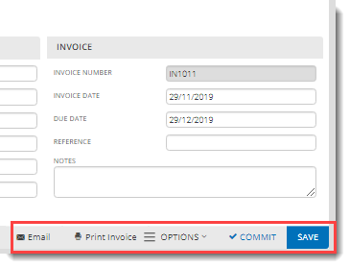

QuickVue displays the new invoice in **Accounts > Invoices** list. Invoices created from a job are displayed with a reference to the job ID.

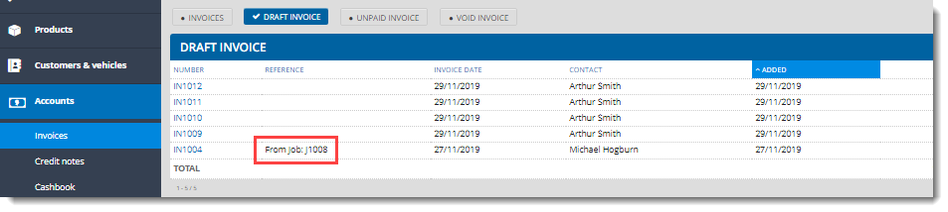

## View or update an invoice

1. Open the invoice using one of the following methods:
   * From the **QuickVue Dashboard**: click **View invoices** in the **INVOICES** section
   * From the **Accounts > Invoices** menu: open the invoice from the list displayed
   * From an open job (or open the job using one of the methods described in View or update jobs: click the draft invoice link above the repair

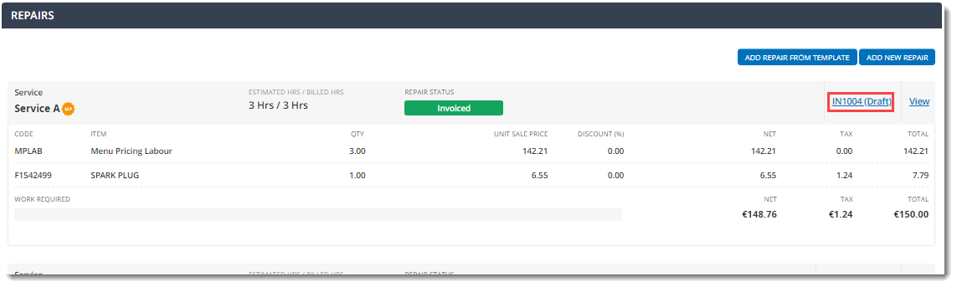

1. Change the invoice details, if required. Note that you can also click **New invoice** to create a new draft invoice instead.

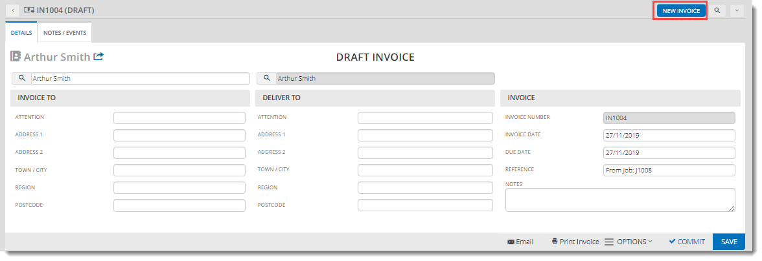

1. When you have finished updating the invoice, click **SAVE** to save it as a draft, or **COMMIT** to commit it.

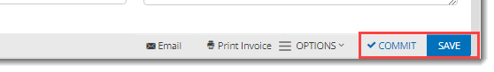

# Manage invoices in QuickVue

This section explains the different operations you can perform on invoices. The functions available in this QuickVue menu can vary according to how your centre is configured.

## Take payment for an invoice

1. Click **Accounts > Invoices** and select your invoice in the list.

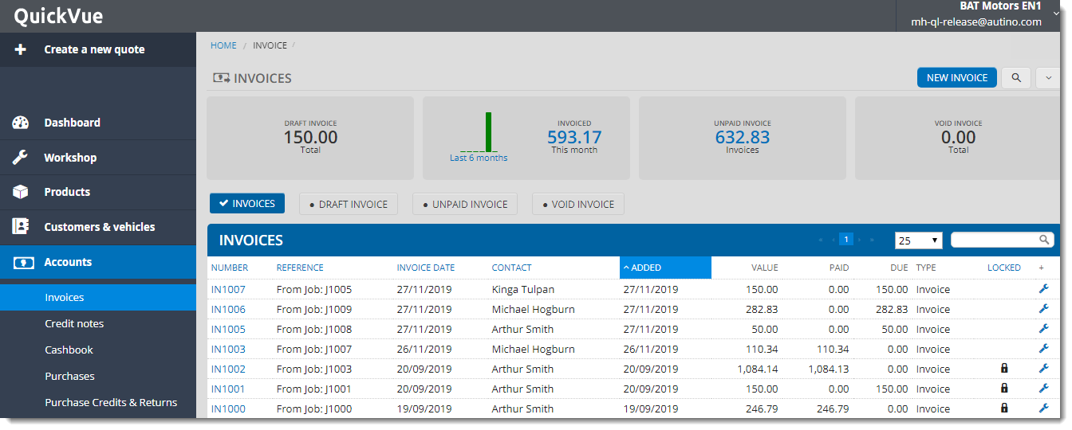

1. Scroll to the **PAYMENTS** section at the bottom of the page and specify details of the payment method and amount, then click **ADD**.

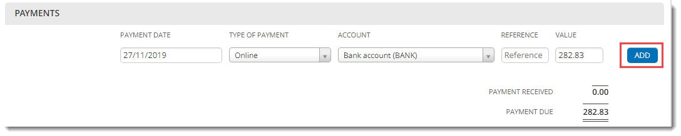

1. If there is an amount available to offset against the invoice, it is displayed at the bottom of the payment section, and you can offset it by clicking **OFFSET**.

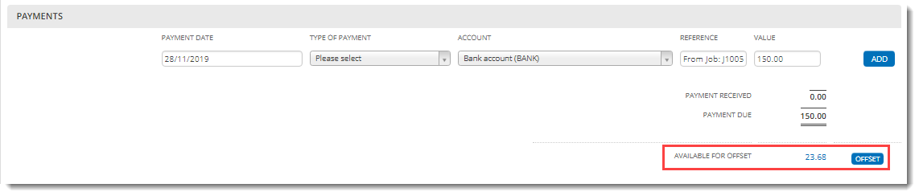

1. If the amount is less than the full amount, the invoice is marked as **part-paid**.

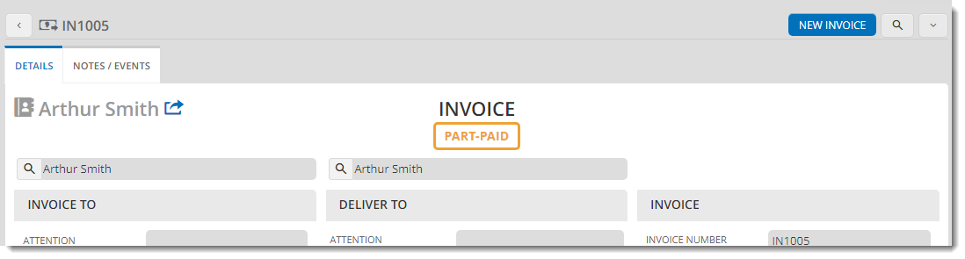

1. If there is still an amount outstanding, you can add subsequent payments in the same way. When the total amount is paid the invoice is marked as **PAID**.

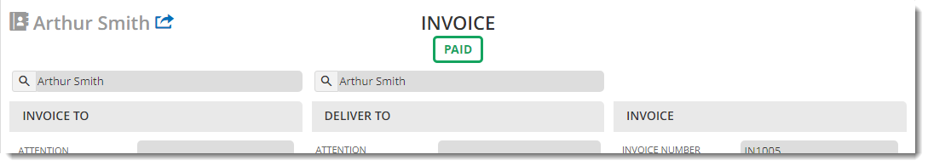

## Void an invoice

After you commit an invoice, if it has not yet been paid you can void it.

Only super users can void invoices. Voided invoices are excluded from your financial reporting and cannot be recovered.

1. Click **Accounts > Invoices** and select your unpaid invoice in the list.



1. Click the **OPTIONS** menu and select **Void**.

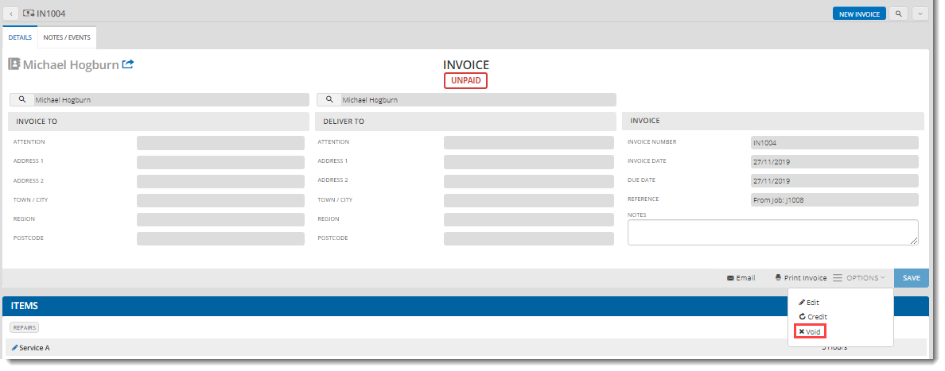

1. Confirm if you would like to print or email the invoice before voiding, then check the confirmation checkbox and click **VOID**.

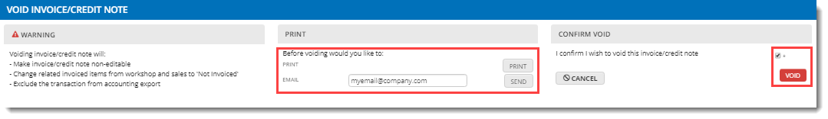

QuickVue marks your invoice as **VOID**.

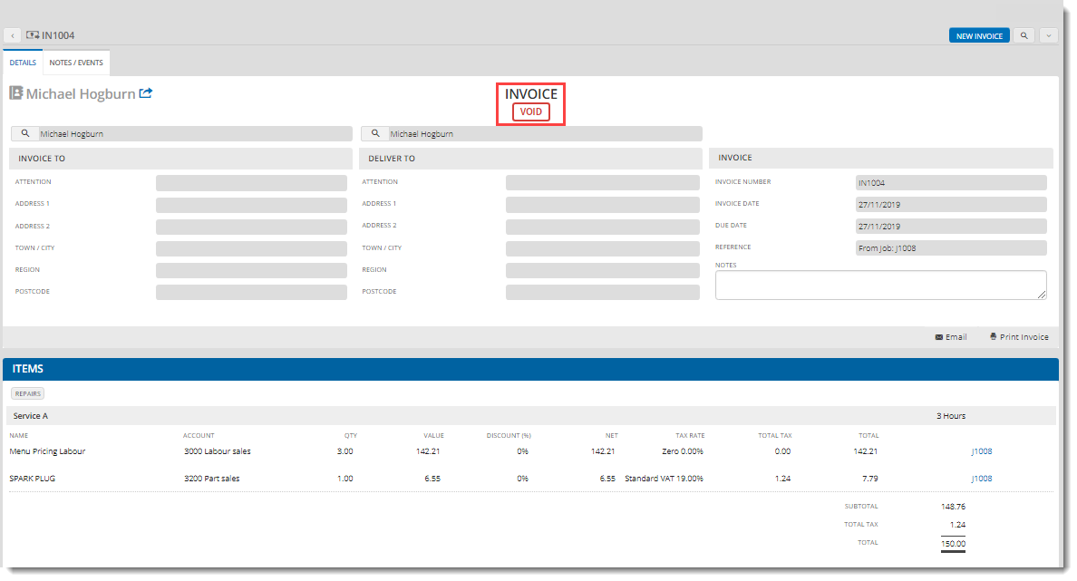

## Credit an invoice

1. Click **Accounts > Invoices** and select your invoice in the list.



1. Click the **OPTIONS** menu and select **Credit**.

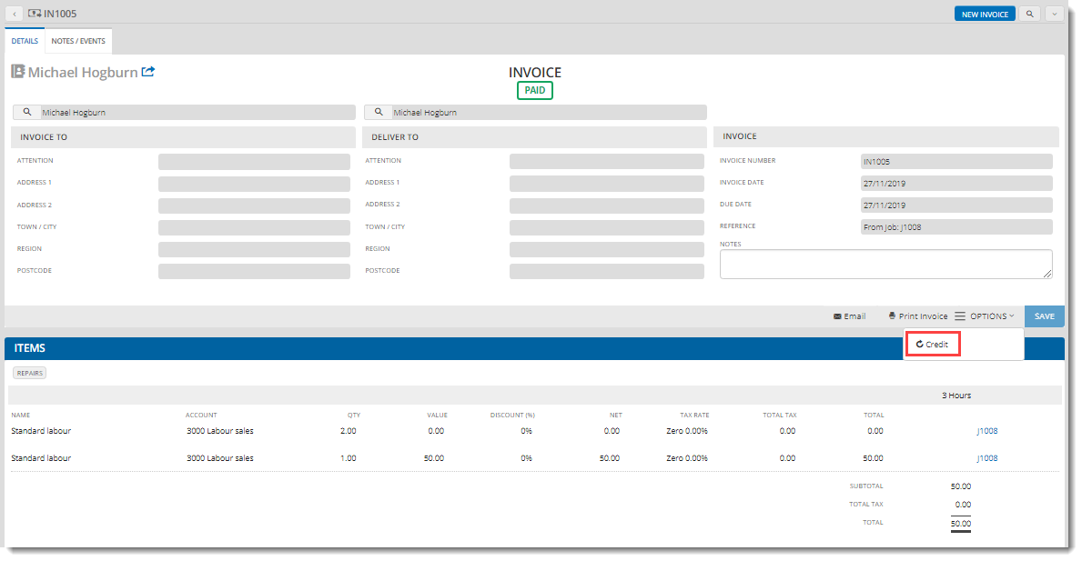

1. Update details of the items to credit at the bottom of the page.

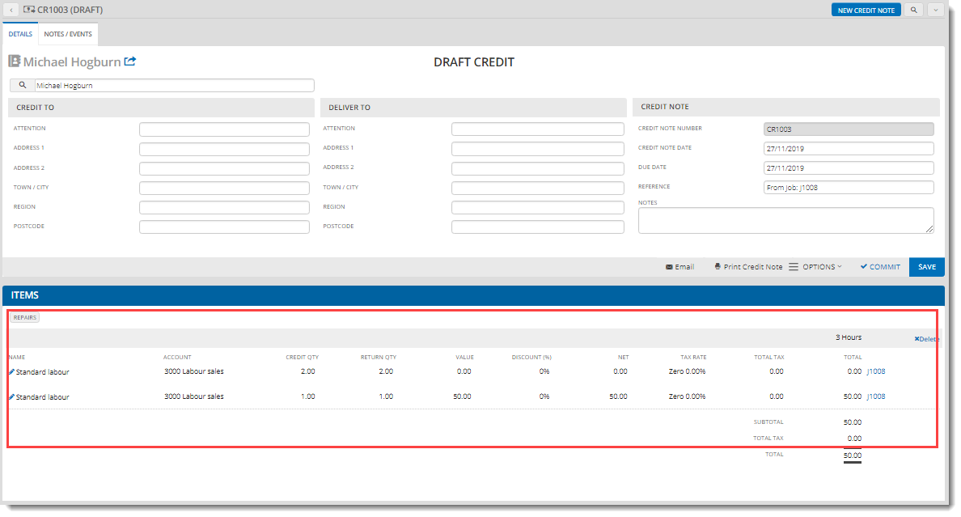

1. Click **COMMIT** to commit the credit note.

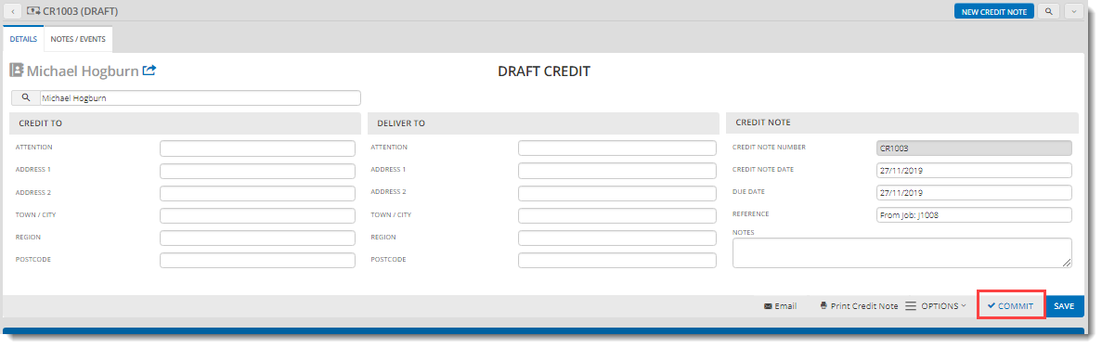

QuickVue creates a new credit note with a status of **UNPAID**.

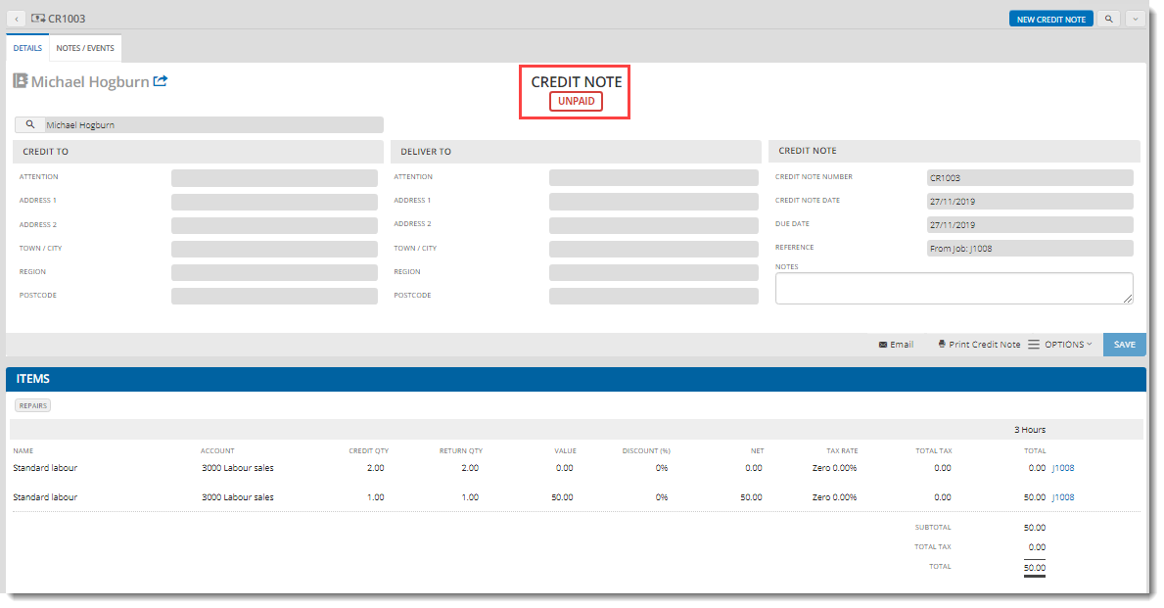

1. In the **PAYMENTS** section, update the payment details, then click **ADD**.

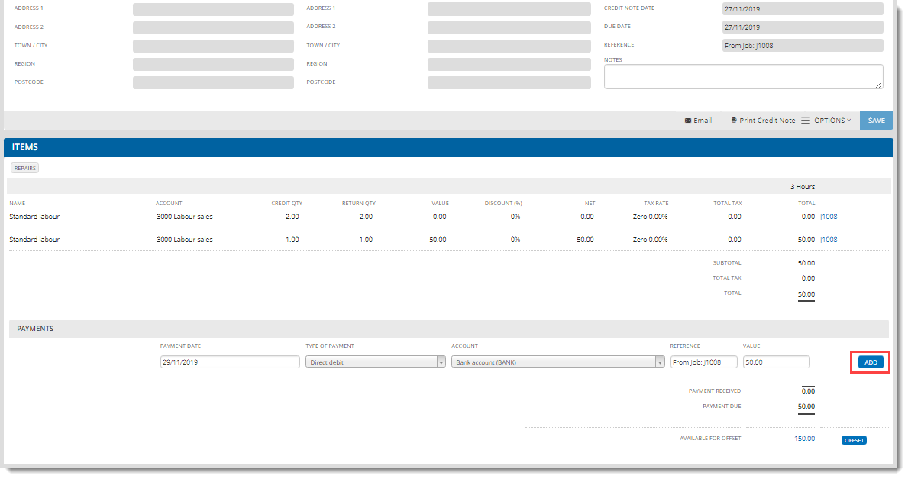QuickVue updates the credit note to **PAID** status.

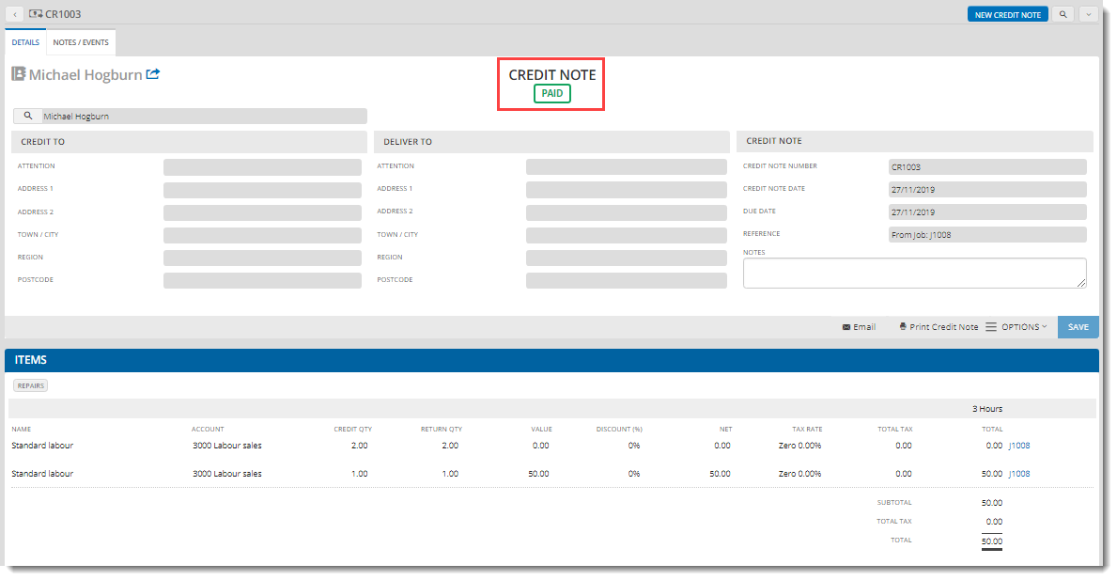

You can also part-pay or offset the credit note as described in Take payment for an invoice.

# Managing purchases in QuickVue

This section explains how to create purchases, receive goods and pay for goods, create purchase credits for suppliers and return goods to suppliers. The functions available in this QuickVue menu can vary according to how your centre is configured.

## Create a new purchase

1. Click **+ Add New** in the **PURCHASES** section of the **QuickVue Dashboard** (or **Purchases** in the **Accounts** menu).

You can also create a new purchase in a product, by clicking **Edit Stock Level** in the product page (see Create a new product for more information).

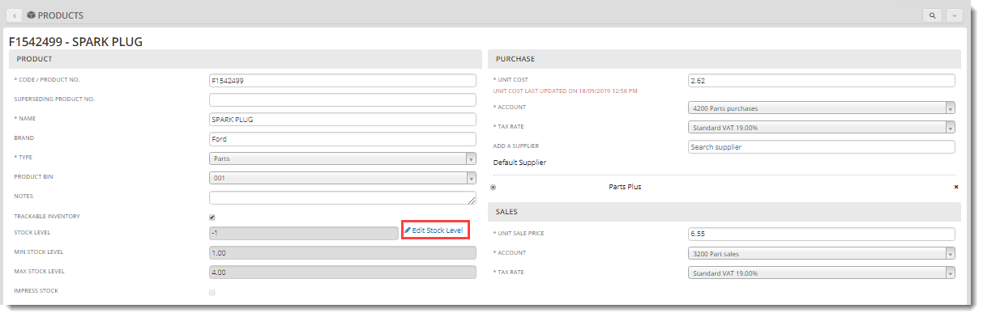

When you click **SUBMIT**, you create a new draft purchase.

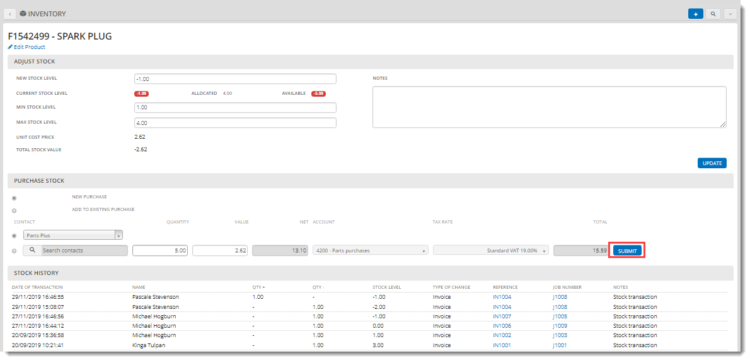

1. Enter the purchase details, including the supplier, the purchaser, the date and the job the purchase is linked to, if any, then click **SAVE**.

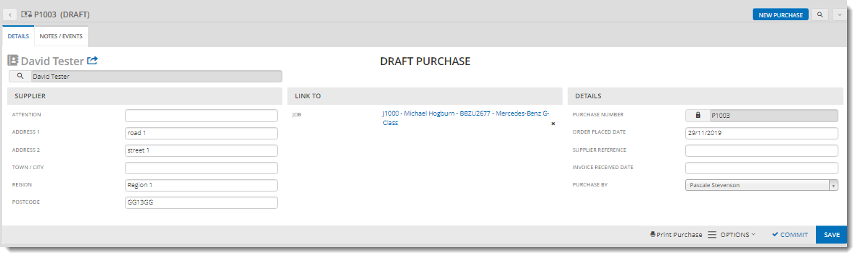

1. Enter details of each purchase item and click **ADD**.

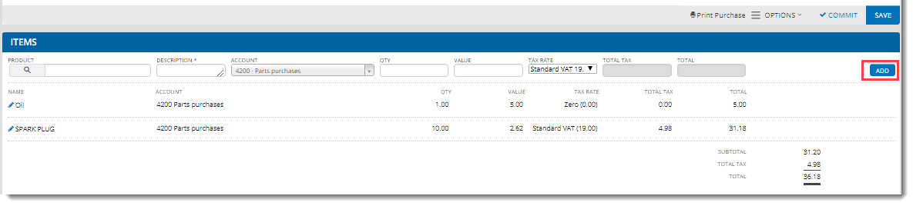

1. Click **COMMIT**.

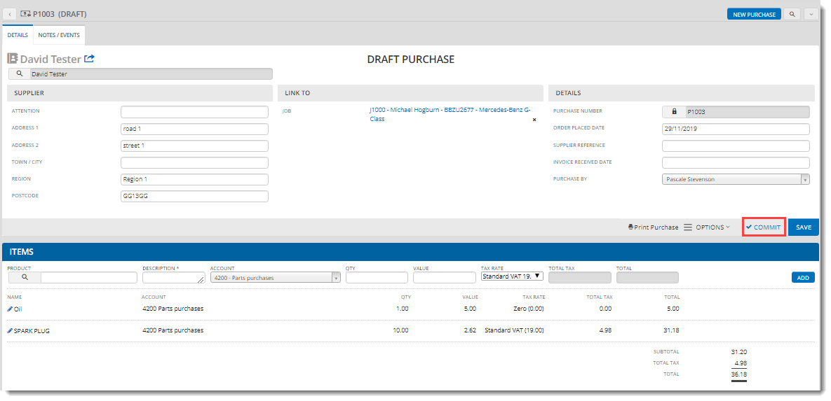

QuickVue updates the purchase status to **ORDER PLACED**.

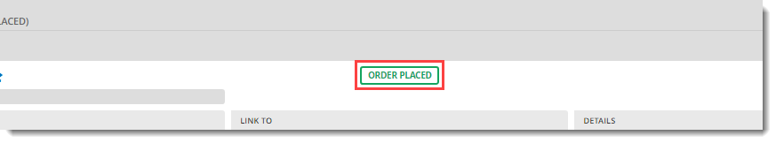

1. You can now email the supplier with details of the purchase.

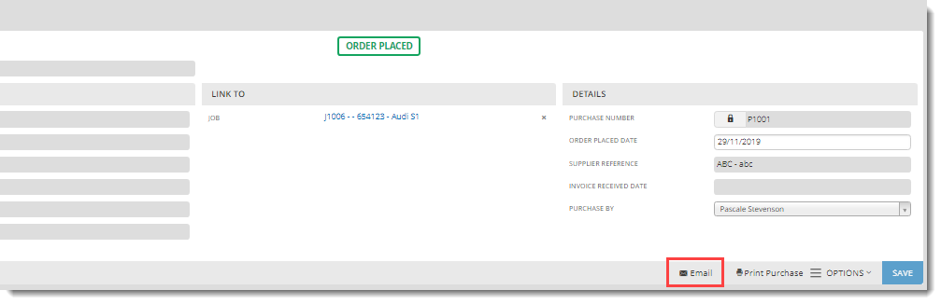

## Receive goods

1. Click **Accounts > Purchases** and select your purchase from the list.

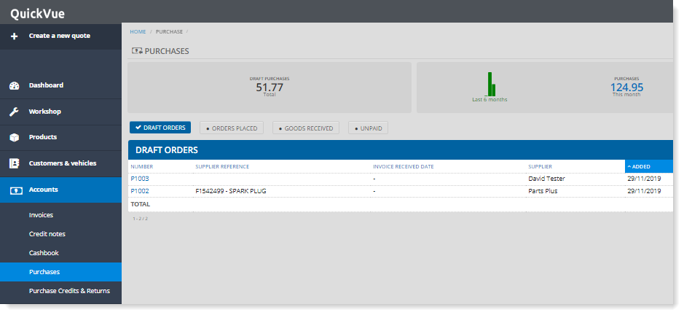

1. In the **ITEMS** section, click **RECEIPT**.

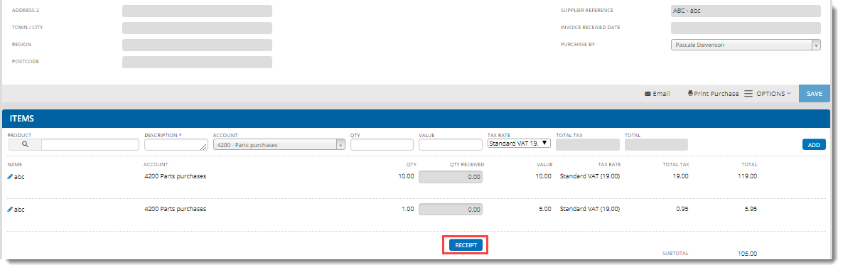

1. Enter the quantity of each item received, then click **RECEIVE**.

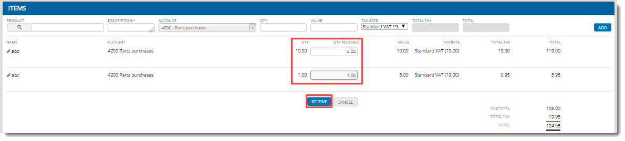

Once all the items are received, the purchase status changes to **GOODS RECEIVED**.

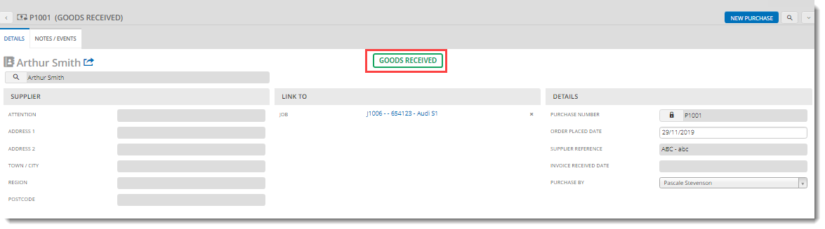

## Pay for goods

1. Click **Accounts > Purchases** and select your purchase from the list.



1. Scroll down to the **PAYMENTS** section and check the **SUPPLIER INVOICE RECEIVED** checkbox.

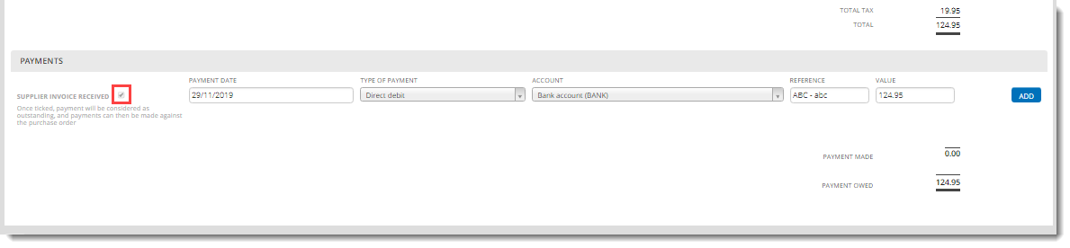

1. Enter the type of payment, the payment amount and click **ADD**. You can enter as many partial payments as you like.

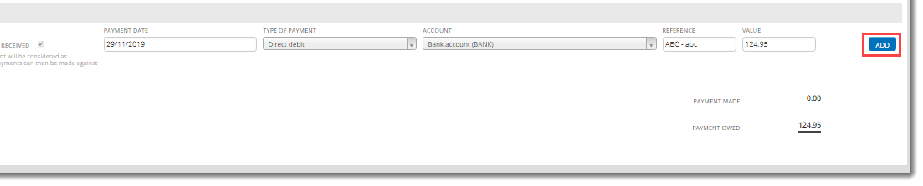

Once all payments are received, the purchase is set to **PAID** and can no longer be edited. If there are any issues with the order, you need to raise a purchase credit.

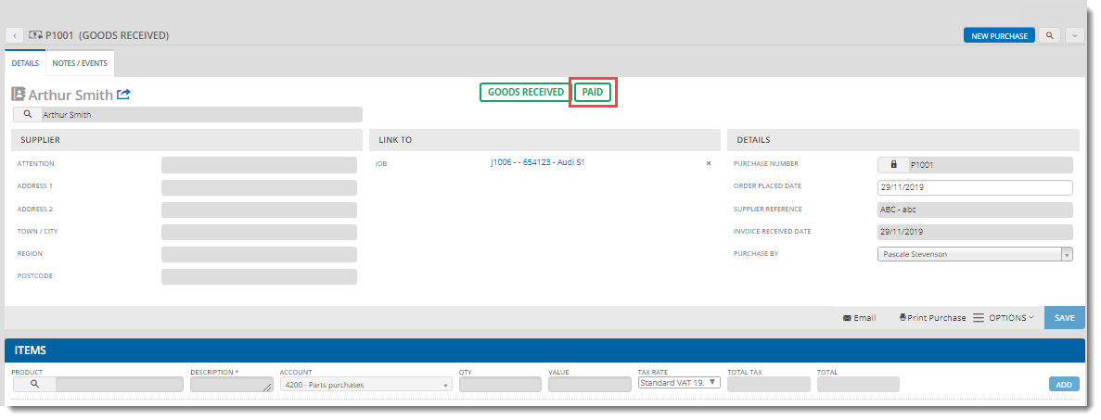

## Create a supplier purchase credit or return

1. Click **Accounts > Purchase Credits & Returns**.

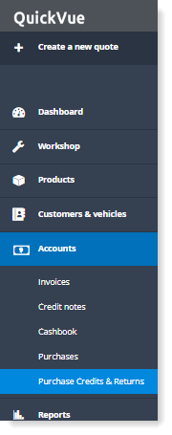

1. Specify the supplier details, link to a job if required and click **SAVE**.

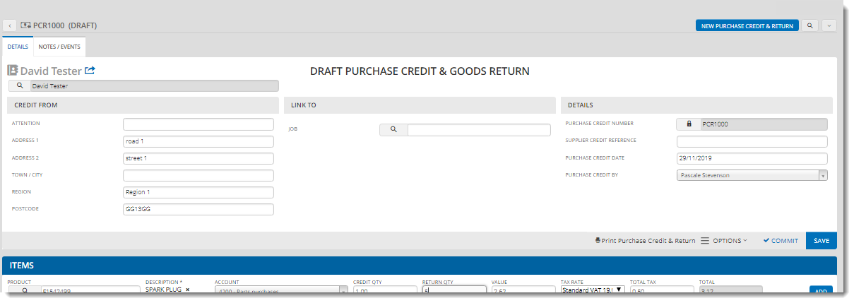

1. In the ITEMS section, specify details of each of the items to be credited and/or returned and click **ADD**.

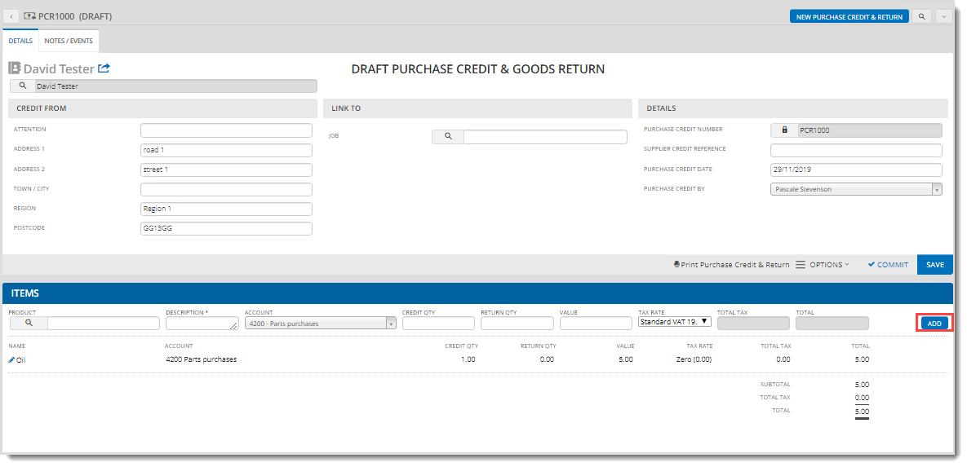

1. When you have finished adding items, click **COMMIT**.

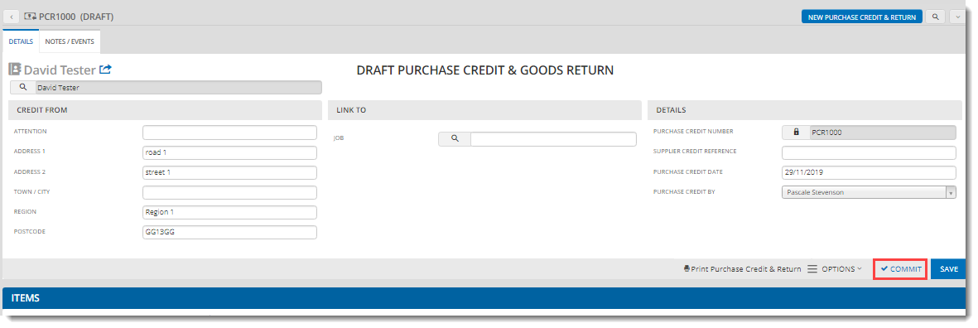

1. The purchase credit / goods return is created with a status of **UNPAID**.

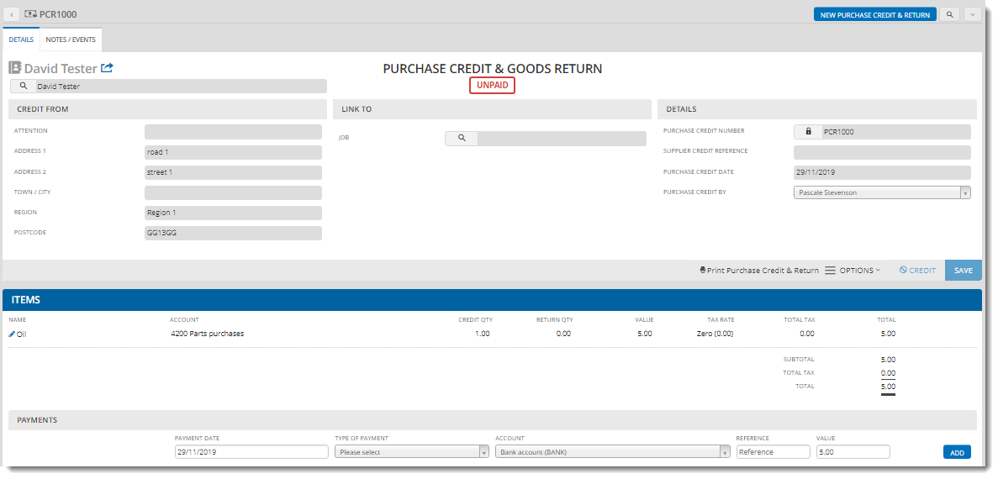

1. Scroll down to the **PAYMENTS** section, enter the payment details and click **ADD**. You can add as many partial payments as you like.

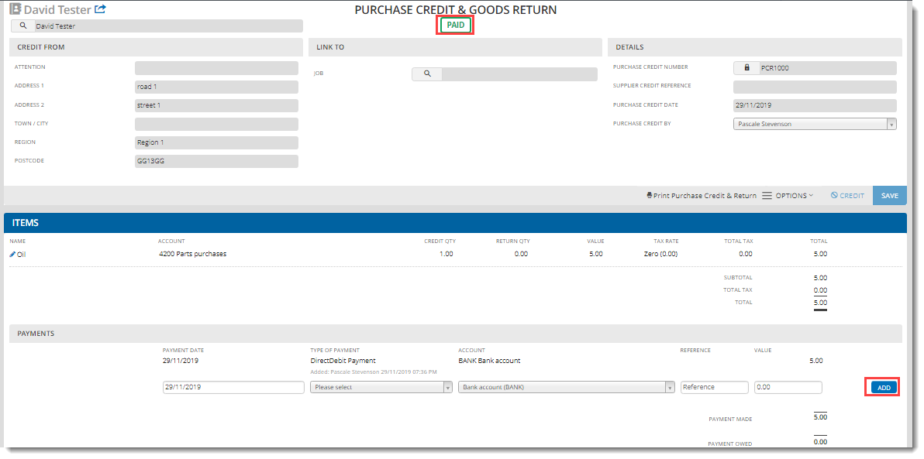

When all payments have been made, the status changes to **PAID**.

# Generating reports in QuickVue

This section explains how to generate reports. The functions available in this QuickVue menu can vary according to how your centre is configured.

## Export invoices to an external accounting system

You can export your invoices and credit notes to a CSV file for import into a third-party accounting system. The format of the file varies, depending on the accounting system you specify. Invoices and credit notes are locked as part of this process, to keep them synchronised after export.

1. Open **Reports > Accounts** and click **CSV export** in the **INVOICES** section.

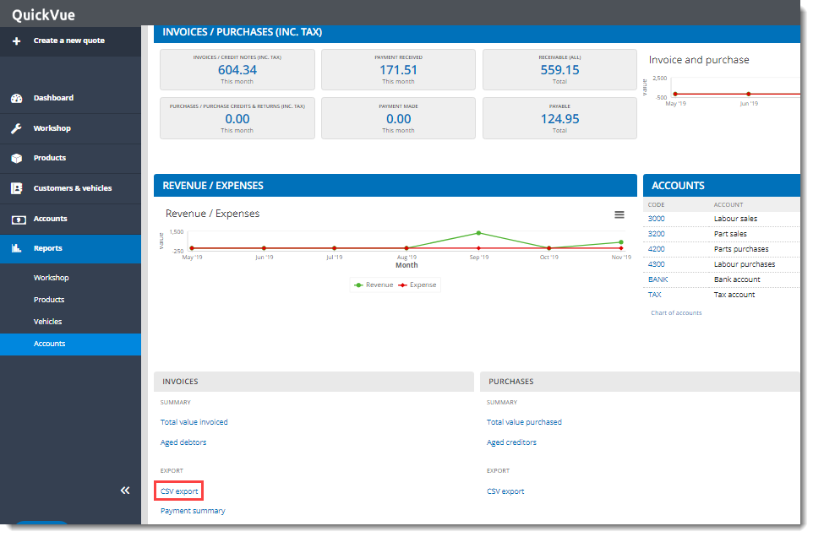

1. Choose your accounting system and the period for export.

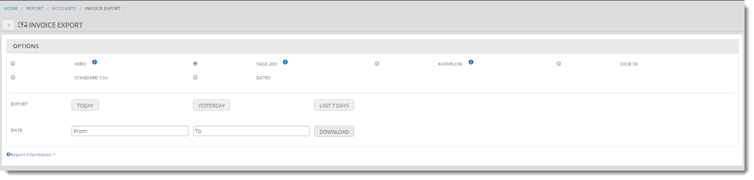

1. When you click one of the export buttons or the download button, QuickVue displays a message warning that the accounting documents will be locked. You can uncheck this option if required (not recommended).

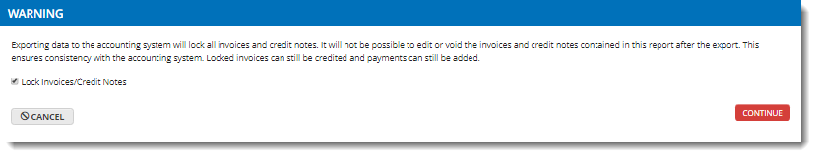

1. Click **CONTINUE** to download your CSV file.

All locked invoices are displayed with a padlock icon in the **INVOICES** list:

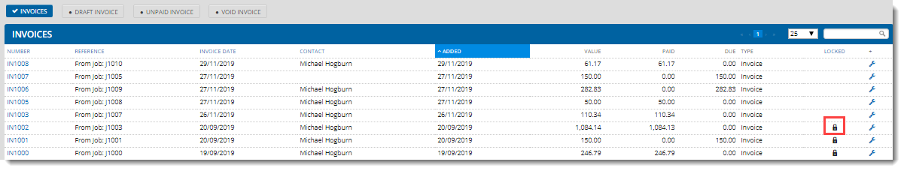

## Workshop reports

You can download the following workshop reports:

* Total jobs completed
* Total value invoiced
* Average jobs completed per day
* Average invoiced per job

To download a workshop report:

1. Open **Reports > Workshop**.

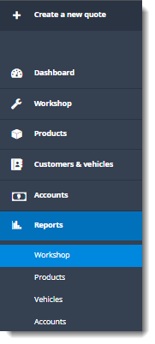

1. Select the report from the drop-down list and click **DOWNLOAD**.

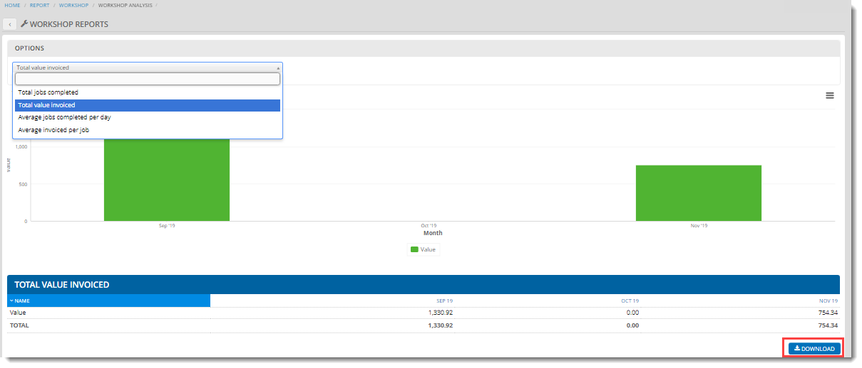

## Product reports

You can download the following product and inventory reports:

* Total quantity invoiced
* Total value invoiced
* Total quantity purchased
* Total value purchased
* Inventory stock check
* Stock replenishment

To download a product report:

1. Open **Reports > Products**.

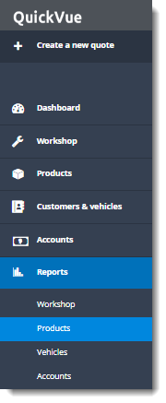

1. Click the link to the required report.

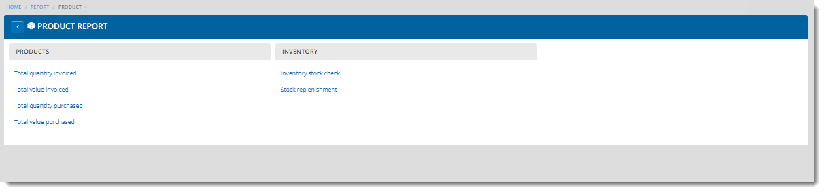

1. Choose the report options at the top of the page, then click **DOWNLOAD**.

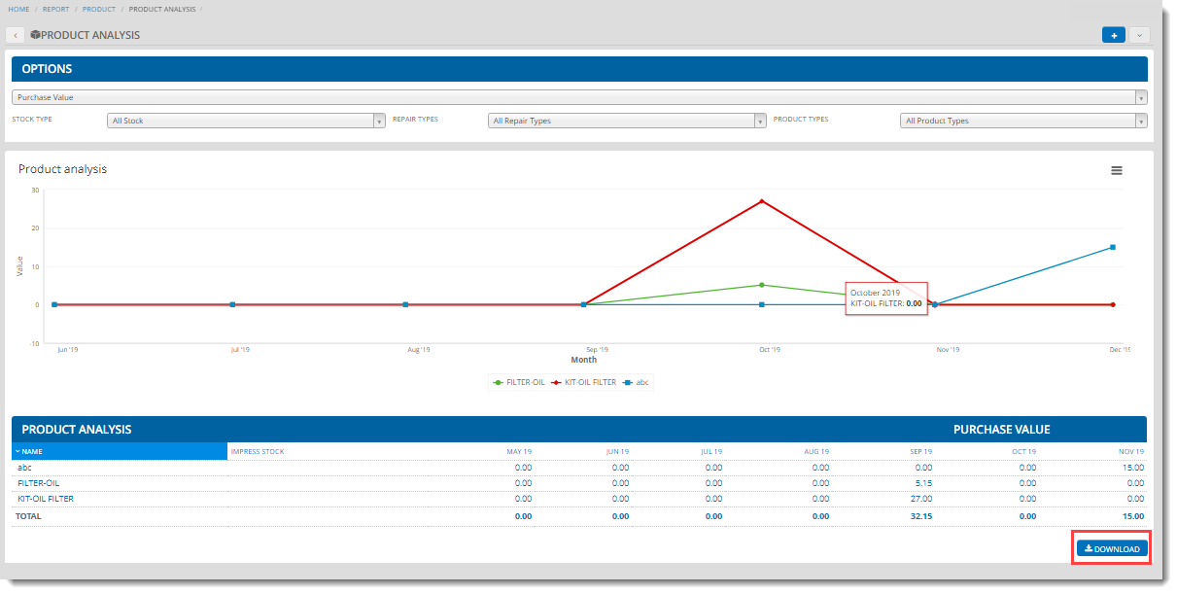

## Vehicle reports

You can download the following vehicle reports:

* Service & MOT
* MOT & Service reminders

To download a vehicle report:

1. Open **Reports > Vehicles**.

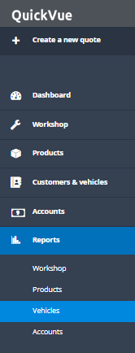

1. Click the link to the required report.

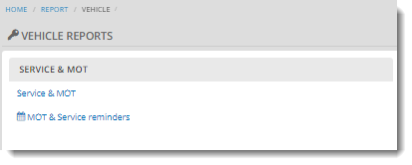

1. Choose the report options at the top of the page, then click **DOWNLOAD**.

